

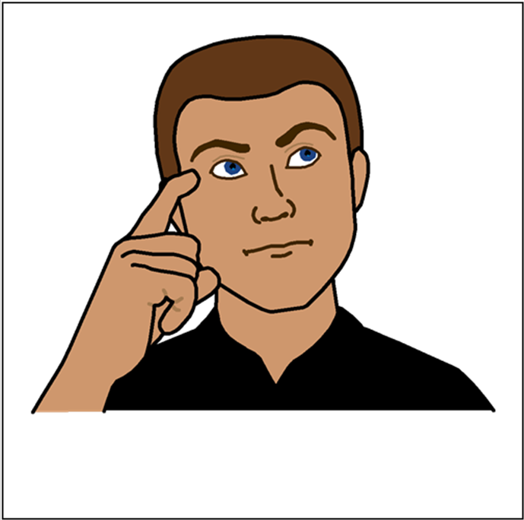

**Tell us what you think**

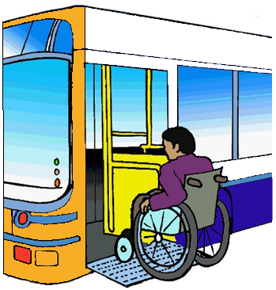It is about public transport for

people with a disability.

Public transport is

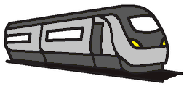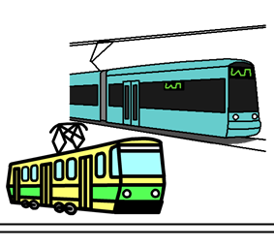

* trains
* light rail
* trams

**and**

* buses

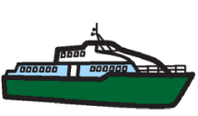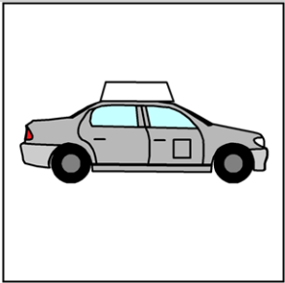

* coaches
* ferries
* taxis

**and**



* planes. Like
* small planes
* big planes
* water planes.

**How to tell us what you think**

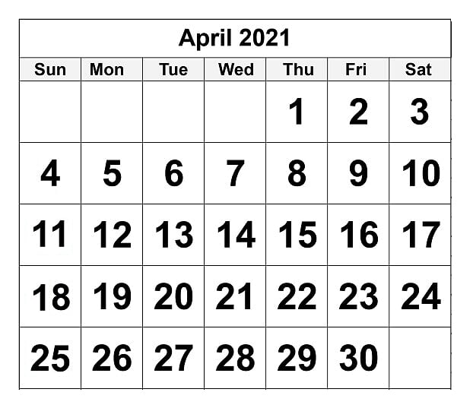

Tell us by Friday 23 April 2021.

Call 02 6274 6188.

We will write down what you say.

**Or**

Email

DisabilityTransport@infrastructure.gov.au

**Or**

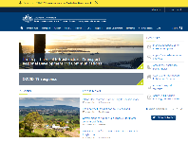

On our website https://www.infrastructure.gov.au



Type the word **disability** in the search window.

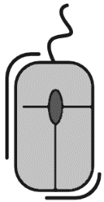Move this page down.

Look for the words Have your say

Click on this link.

.

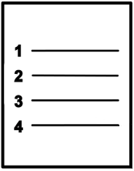There is a form with questions.

Write what you think.

**Or**

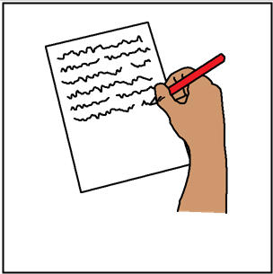

Write a letter.

Send it to

Disability and Transport Standards Section

COVID Freight and Logistics Branch

Department of Infrastructure, Transport, Regional Development and Communications.

GPO Box 594

Canberra ACT 2601.

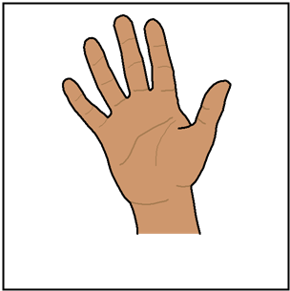**Our 5 questions**

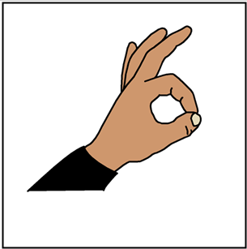You do **not** have to do every question.

Like you can do 1 question. That is OK.



1. You have a disability. You use public transport. What is good for you?



1. You have a disability. You use public transport. What needs to be better for you?

Read **Public transport for people**

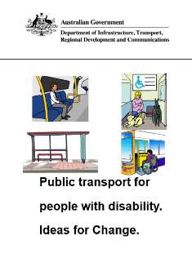

**with disability. Ideas for Change.**

It will help you tell us what you think.

There are 16 ideas for change.

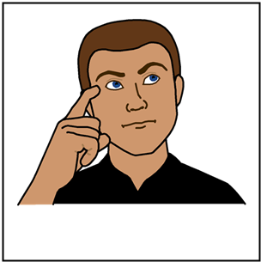

1. Read each idea.

Think about each idea for change.

What steps do we need to make each

idea happen?



1. Do you have more ideas for change?
2. We plan to do changes.

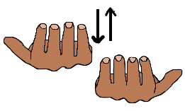

What will this mean for you?

Will it make your use of public transport

* good
* the same
* hard?



Think about things that may change. It may be

* cost
* other things you may need.

Like a new wheelchair to lock in to the bus.

This is the end of the questions.

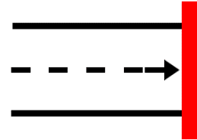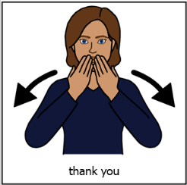

Thank you.

**More information**



The full report and ideas for change are at https://www.infrastructure.gov.au



Type the word **disability** in to the search window.

**Images**

We used images from

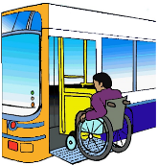

* Inspired Services
* Picto-selector
* Spectronics
* The Noun Project
* Tobii-Dynavox.

**Where is this information from?**

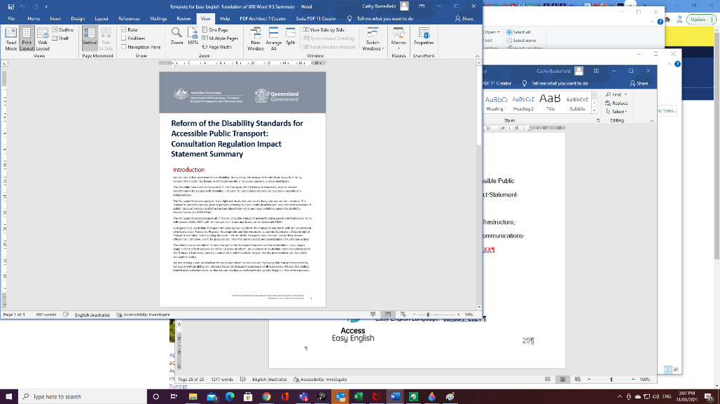

This information is based on the Reform of the Disability Standards Accessible Public Transport. Consultation Regulation Impact Statement Summary from the Australian Government Department of Infrastructure, Transport, Regional Development and Communications and the Queensland Government. February 2021.