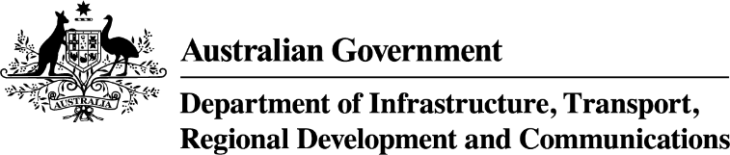

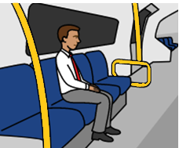
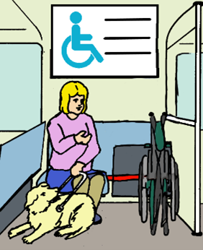

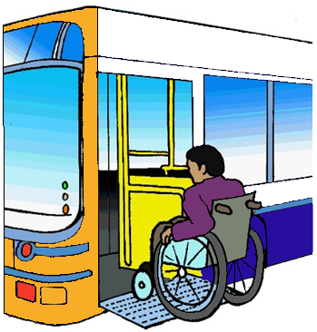
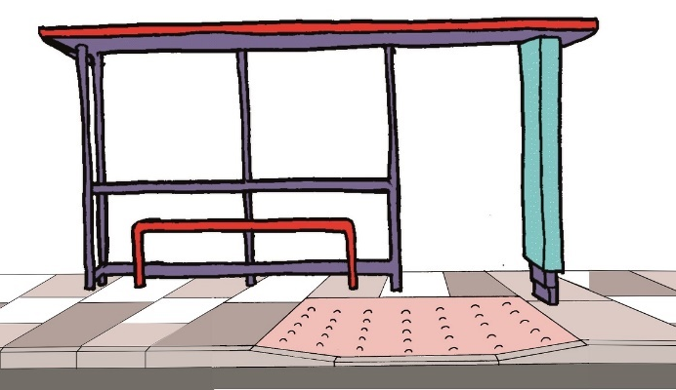

Public transport for people with disability.
Ideas for Change.

- in 5 people has a disability.

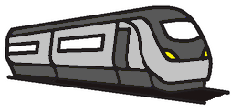
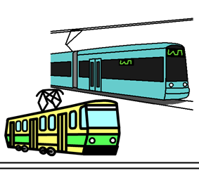
Public transport is
- trains
- light rail
- trams

and

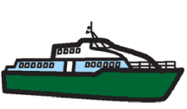
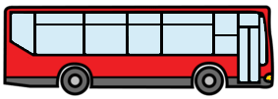
- buses
- coaches
- ferries
- taxis.

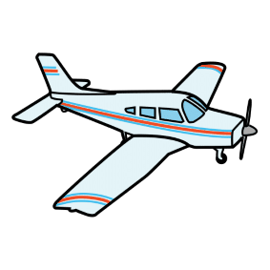
Public transport is also planes. Like
- big planes
- small planes
- water planes.

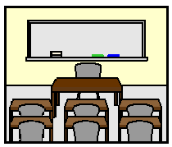
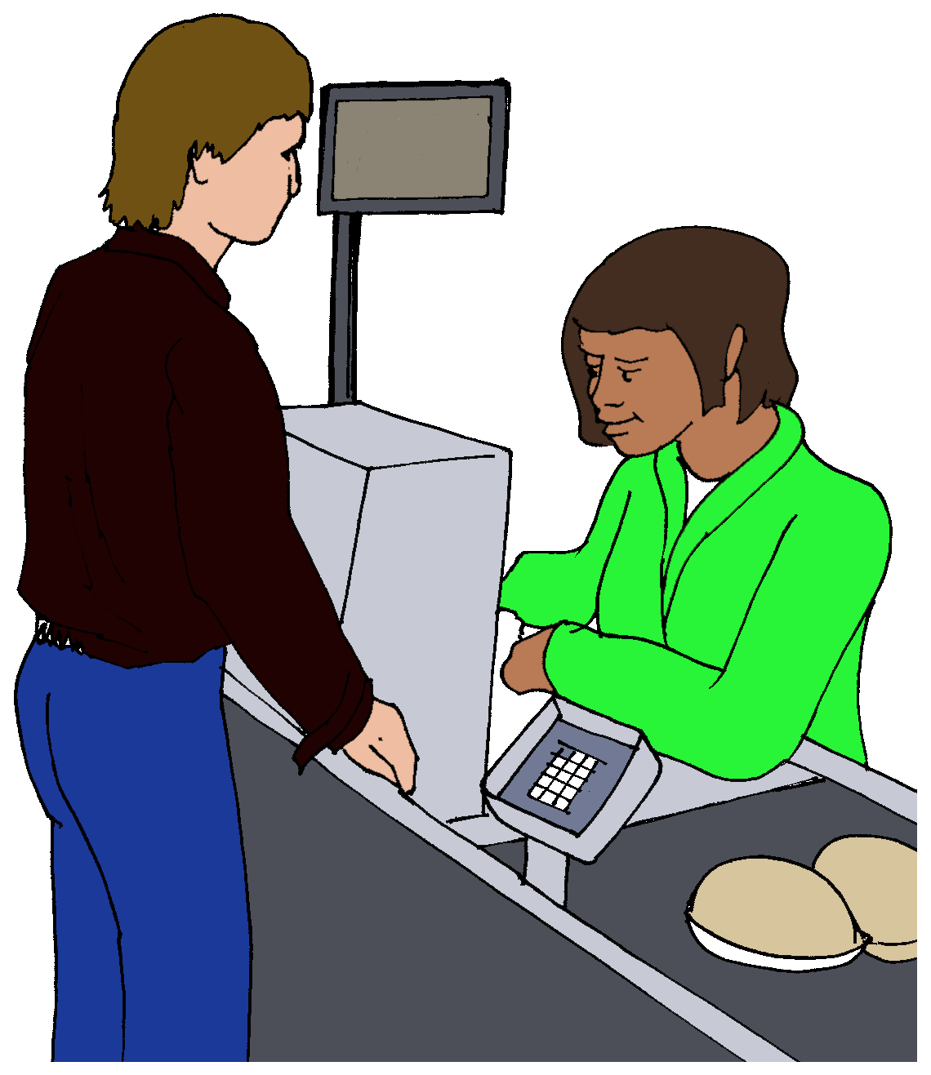
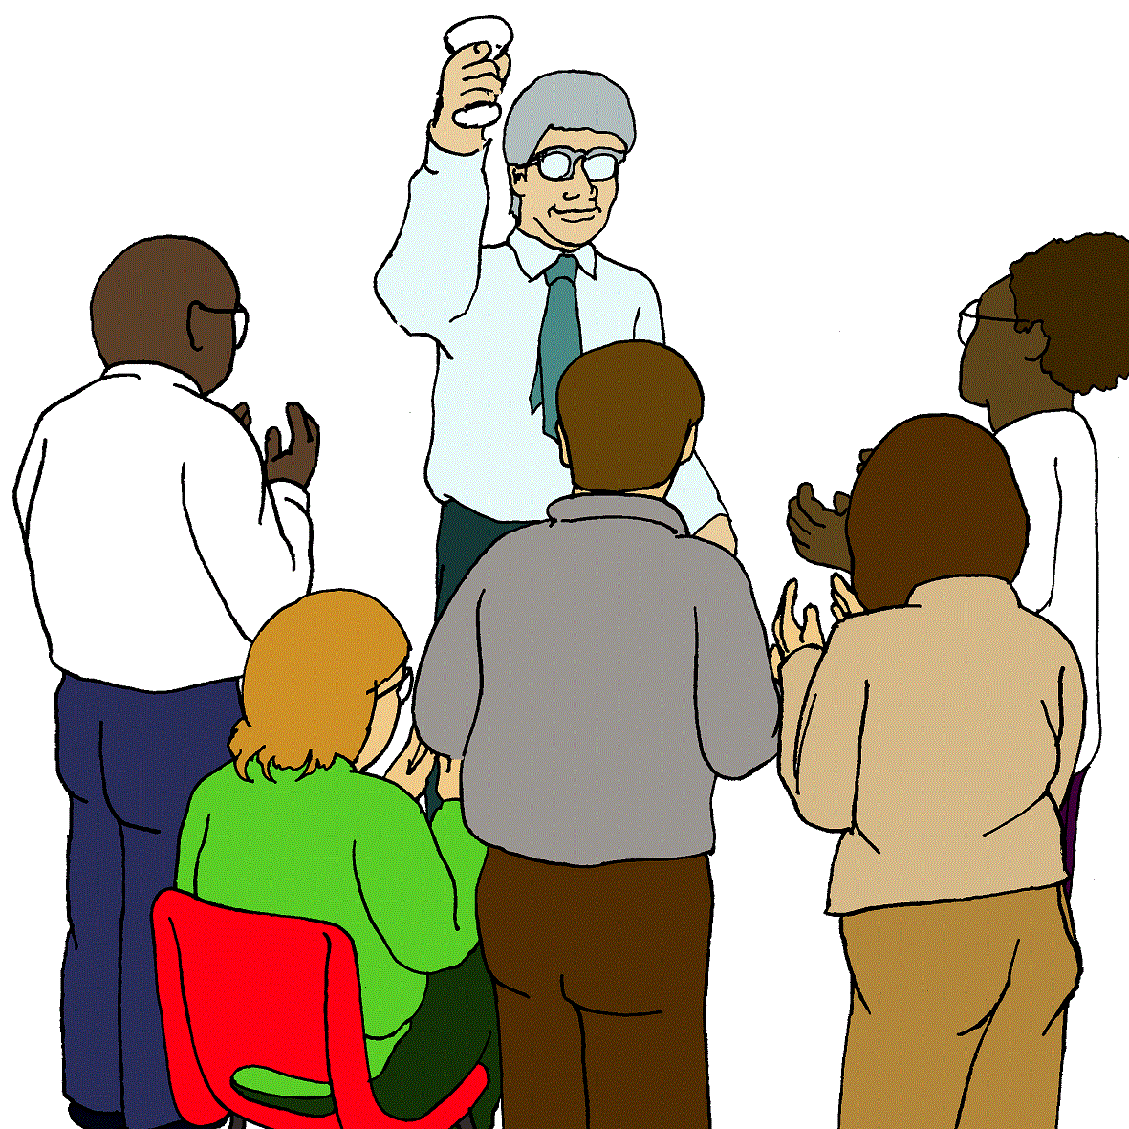
People with disability use public transport.
Like to go to
- work
- school

- shopping

- meet friends.
It is your right.
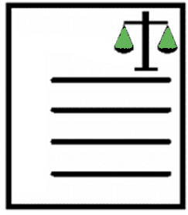
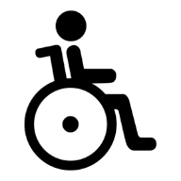
Public transport must follow the rules for access.
The rules are in a law. It is for all of Australia.
The law is the Disability Discrimination Act 1992.

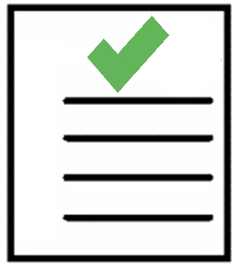
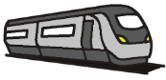
The name of some of the rules are the Disability Standards for Accessible Public Transport 2002.

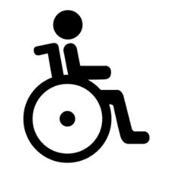
It says public transport must be safe for
      - people with disability

and

      - people with no disability.

It also says public transport must be easy to use
      - for people with disability
and
      - for people with no disability.

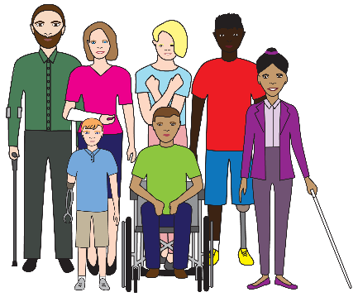
You have a disability. We want to know
what you think about access to public transport.

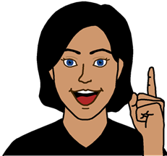

We have lots of ideas for change.

We want to hear from you.
Read Tell us what you think.

Ideas for change

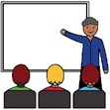
- Do we teach staff about people with disability?
What information do we need to teach?

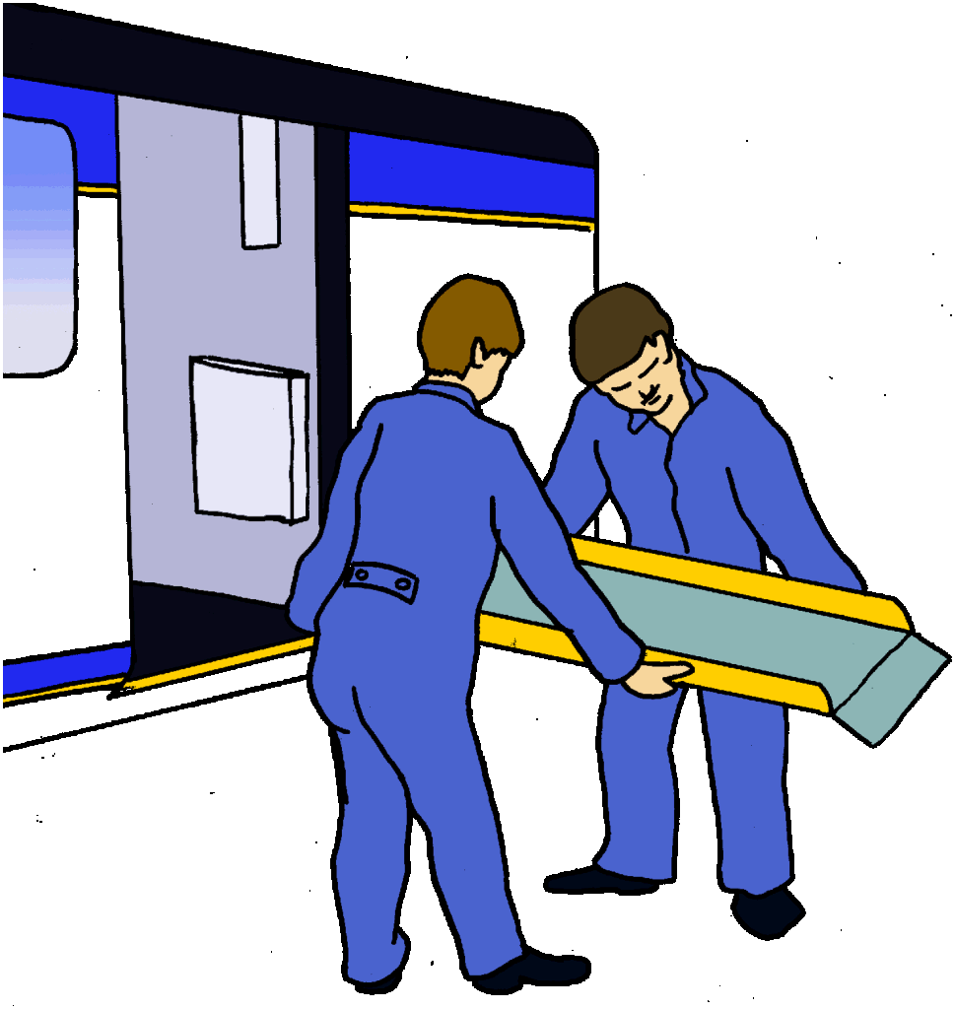
Like how to
        - set up a ramp

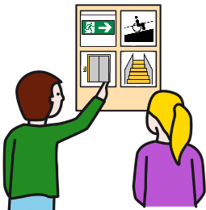

        - talk to a person with a communication aid.

- Think about on a
        - bus
        - light rail
        - tram.

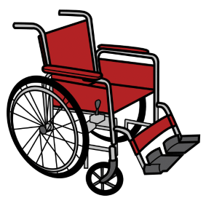
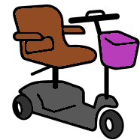
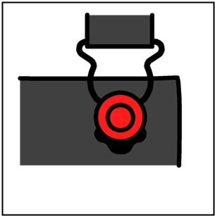
Tell us about the places to lock in your
        - wheelchair
        - walker
        - scooter.

Do you feel safe?
What can we do to make you feel safe there?

- Do we need more disability
        - seats
        - places?

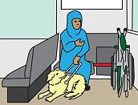
Are they in the right place? Like
        - the front of a bus
        - they face the middle
        - they face the front.

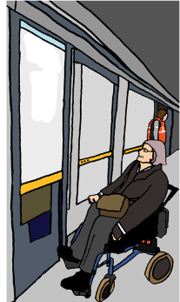
- Can you use the disability seats? Like
        - you can move around other things to the seat
        - you know which carriage on a train.

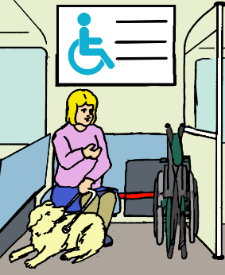
Think about the signs for disability seats. Like
        - are they clear?
        - can you read them?

        - are at the right height?
        - other people know who the seat is for?
        - you can ask for this seat?

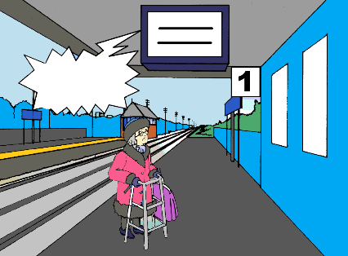
- Public transport use TV screens to
- tell you where to go
- the time your public transport goes
- when it is late
- when it is not coming.

Think about the screen.
Is the height of the screen OK?
Are the size of the words OK?

Can you read the words?
Do you know what the words mean?
Do the different colours help you?

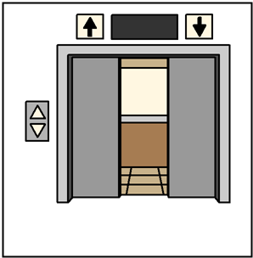
- Think about lifts in public places. Like
- hospitals
- shopping centres

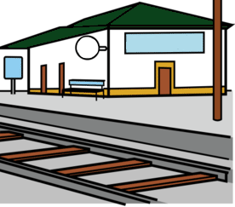

Think about lifts at train stations.

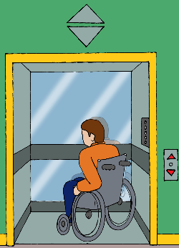
- can you fit in the lift?
- can the people you are with also fit in?
- can you hear the recorded voice in the lift?
- can you read the signs in the lift?
- what help may you need to use the lift?

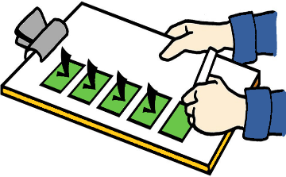
Do we need plans for when we check all lifts? Like the lifts at the airport are checked in May.
- Public transport use websites.
Like www.transport.act.gov.au
They tell you
- where to go
- what time your public transport goes
- when it is late
- when it is not coming.

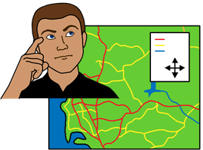

You can plan all your trip on their websites.

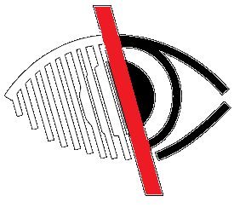
Do websites need to have better access?
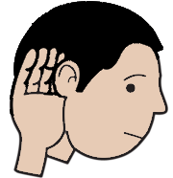
Like for people who
- are blind or vision impaired
- are Deaf or hearing impaired.
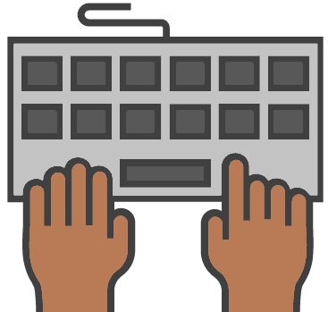
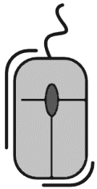
Do websites need to have better access?
Like for people who
- can not use a mouse
- can not use a keyboard

or

for people who
- find it hard to read
- can not use a computer

or

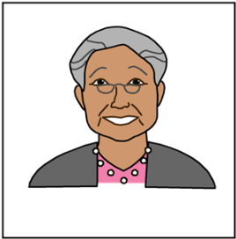
- are an old person
- use a different language.

- Staff do need to mend public transport.
Like the train track is old.
It needs a new train track.

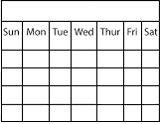
Some times it is planned.
Like we know it will be in 2 days.

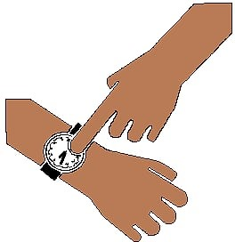
Some times it is not planned.
Like the over head wires come down.
It needs to be fixed now.

How can we make sure you know about this?
How can we tell you this information? Like in
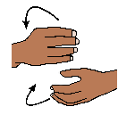
- Auslan
- Easy English

- so you can listen to it
- large print.

- Some people use ferries.

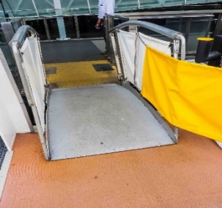
Different times of the day can make the ramp
- easy to use
- hard to use.

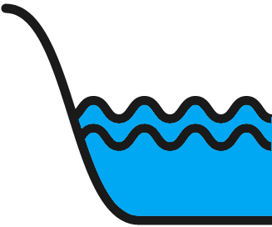
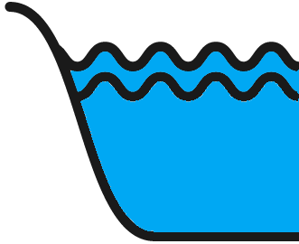
Think about when you use the ramp.
Do different tides make a difference for you?

Do you feel safe to use them
- at high tide?
- at low tide?
- all the time?
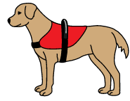
- Some people need an animal to travel.
Animals need to go to the toilet.
What rules do we need for animals? Like
- for your guide dog
- for your companion dog.

- You are in a public transport area.
There is danger. Like a bus is out of control.
You are at the bus stop.
The bus looks like it may hit the bus stop.

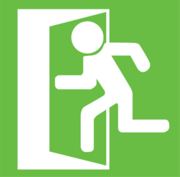
What things do we need to keep you safe? Like
- to leave an area
- the information we say
- places to wait until it is safe.
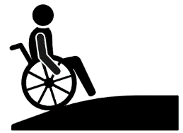
- Some people need to use
- lifts
- ramps.
They can not use the stairs.

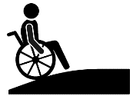
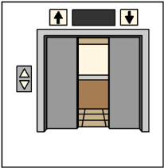
What rules do we need for people?
Think about
- when it is busy
- there are a lot of people around
- you need to leave fast. It is an emergency.

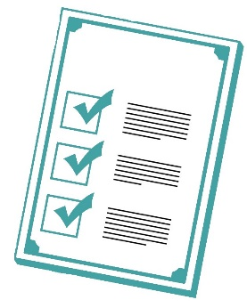
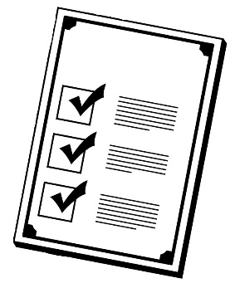
- There are rules to help you move around. Different transport departments use
different rules.

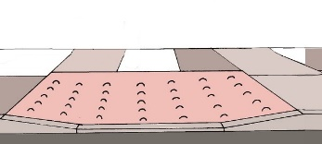
They have
- signs to tell you where some thing is
- arrows on the ground
- bumps and lines on the ground
- a lot of colours.

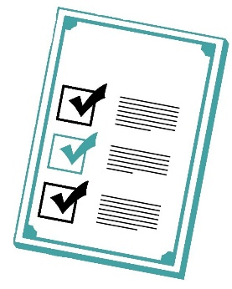
Some areas have rules
- the same
- not the same.
How can we have a list of rules the same?

- For people who are blind or vision impaired.

Think about the tactile markers on the ground.

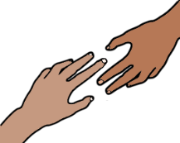
Do you need more information about them?
Are they clear?
Do they help you know which way to go?

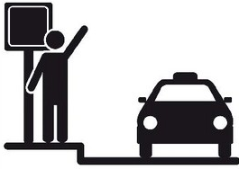
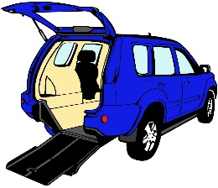
- Think about places you
- get dropped off
- picked up.

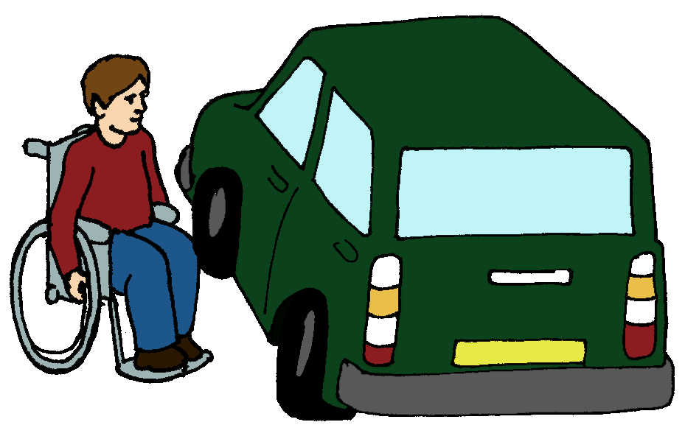
It may be in
- a car
- a taxi.

It needs to be safe.
What do you need to be safe?

- You need public transport information.
The information is on websites only.

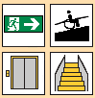
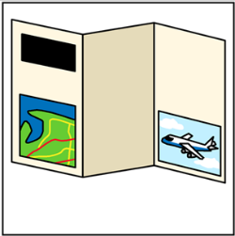
What other ways do we need information? Like
- in print
- Easy English
- so you can hear it
- pictures.

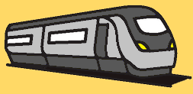
There are rules about access to
public transport. We wrote them in 2002.
It is a long time ago now.
They need to be right for 2021.
We plan to do the new rules with this work.
More information

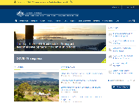
The full report and ideas for change are at https://www.infrastructure.gov.au

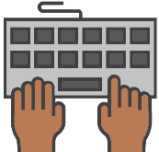

Type the word disability in to the search window.

Images
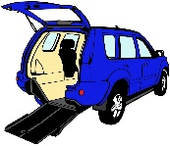
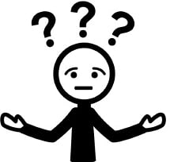
We used images from
- Change People
- Inspired Services
- Picto-selector
- SocialBuzz
- The Noun Project
- Tobii-Dynavox.

Where is this information from?
This information is based on the Reform of the Disability Standards Accessible Public Transport. Consultation Regulation Impact Statement Summary from the Australian Government Department of Infrastructure, Transport, Regional Development and Communications and the Queensland Government. February 2021.

