Changes to coronavirus (COVID-19) restrictions from 19 July
Easy read information for people with disability
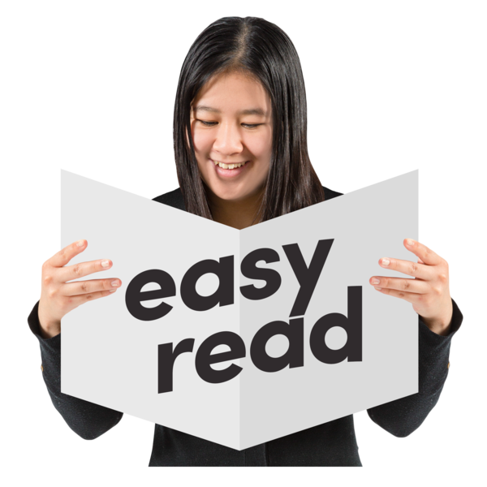

About this book
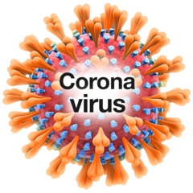 | Coronavirus has meant changes to the way we do things.  Coronavirus is also called COVID-19.
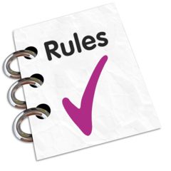 | The Victorian Government has made some rules to help slow the spread of coronavirus and keep us safe.
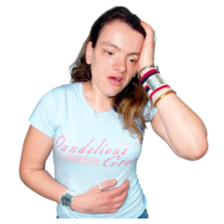 | The number of people getting coronavirus has increased again.  That is why the Victorian Government has changed some of the rules.
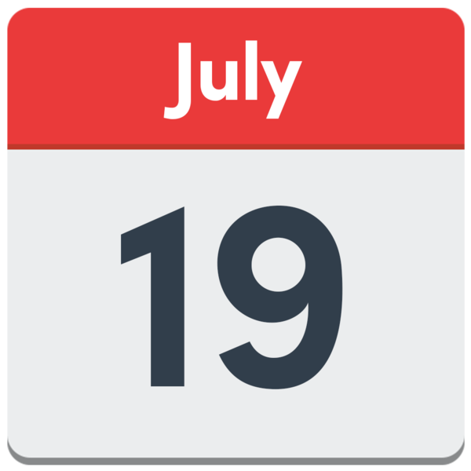 | This book will tell you how the rules have changed in some parts of Victoria.  The rules changed from  19 July 2020.
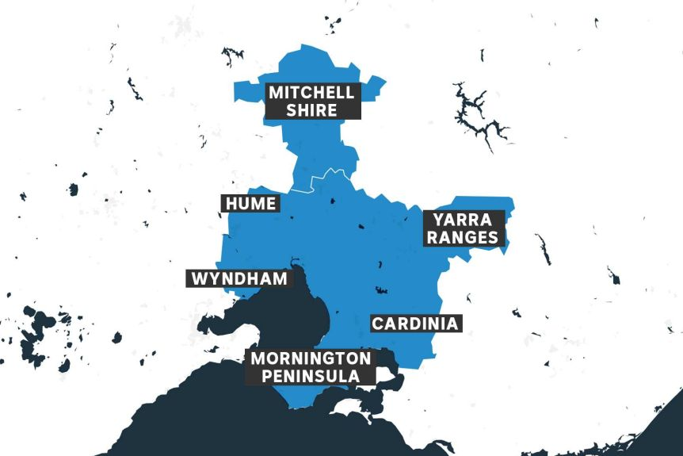 | These rules apply to people living in the greater Melbourne area (all of Melbourne) and Mitchell Shire.
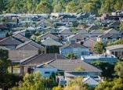 | People living in these areas need to follow the new rules.

Which areas are restricted?

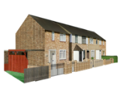 | The rules have changed for people living in the greater Melbourne area and Mitchell Shire.  These areas include the Council areas of:
 | - Banyule  - Bayside  - Boroondara  - Brimbank  - Cardinia  - Casey  - Darebin  - Frankston  - Glen Eira  - Greater Dandenong  - Hobsons Bay  - Hume  - Kingston  - Knox  - Manningham  - Maribyrnong | - Maroondah  - Melbourne  - Melton  - Mitchell Shire  - Monash  - Moonee Valley  - Moreland  - Mornington Peninsula  - Nillumbik  - Port Phillip  - Stonnington  - Whitehorse  - Whittlesea  - Wyndham  - Yarra  - Yarra Ranges

What rules have not changed?
The Victorian Government has made some rules to keep people safe and healthy.

These rules have not changed.

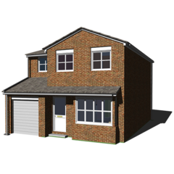 | These rules tell us to stay home if we are not well.
If you are not well, you should get tested for coronavirus (COVID-19).
You can go to a test site near your home. For testing information please go to the Department of Health and Human Services website <https://www.dhhs.vic.gov.au/getting-tested-coronavirus-covid-19>.

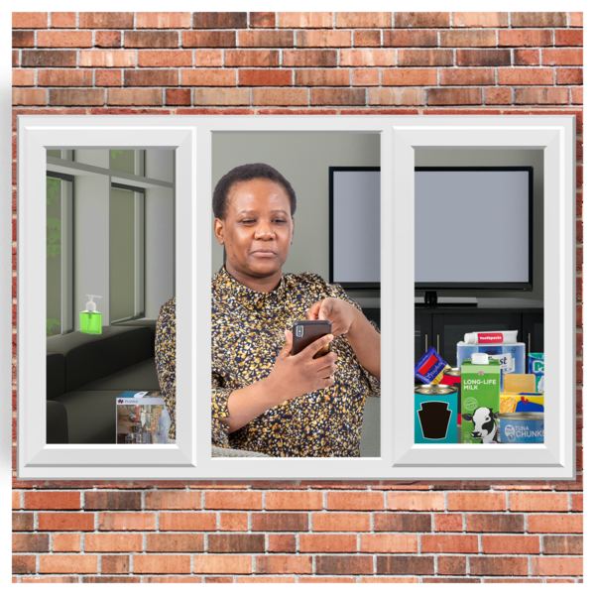 | You must return home after the test.  You must stay at home until you get your test result.
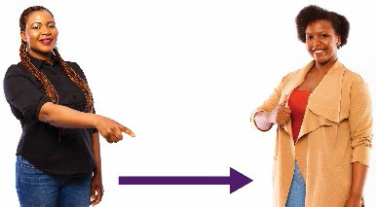 | The rules tell us to use physical distancing.  Physical distancing means you keep space between you and other people.  You need to stay 1.5 metres away from other people.  1.5 metres is two big steps away from someone.
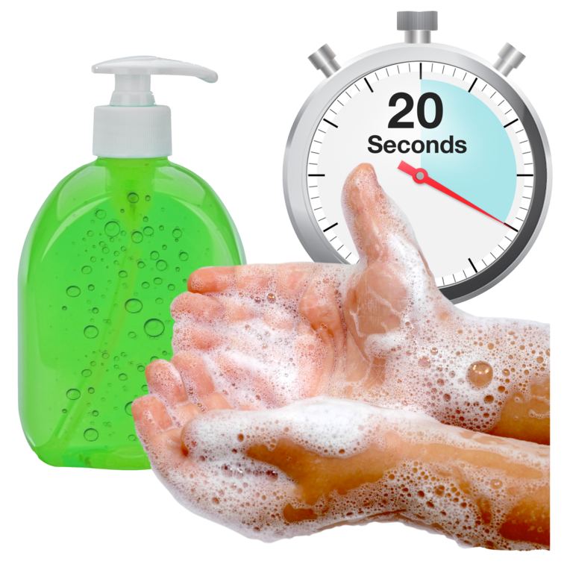 | The rules tell us to wash our hands with soap and water for at least 20 seconds:  - after you cough or sneeze  - before and after you eat  - after you use the toilet.
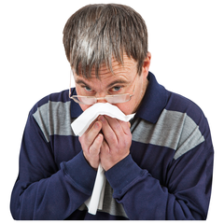 | The rules tell us to cover our mouth and nose with a tissue when we cough or sneeze.  If we don’t have a tissue, we should cough or sneeze into our elbow.
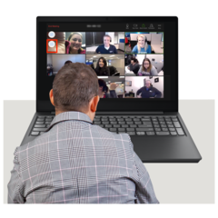 | The rules tell us to keep working from home if we can.  This will help stop you and others from getting coronavirus (COVID-19).

What rules have changed?
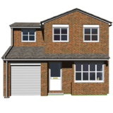 | If you live in the greater Melbourne area and the Mitchell Shire there are only four reasons to leave your home.

Shopping for food and basic things
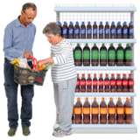 | You can leave your home to shop for food or basic things, like soap and tissues.  You must only leave your home to buy things you really need.

For work or study
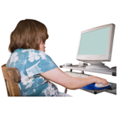 | You can leave your home to work or study.  You must only leave your home to work or study, if you cannot do this from home.

To give or receive care
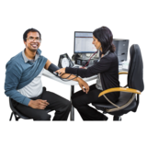 | You can leave your home to:  - see a doctor  - care for someone else.

For exercise
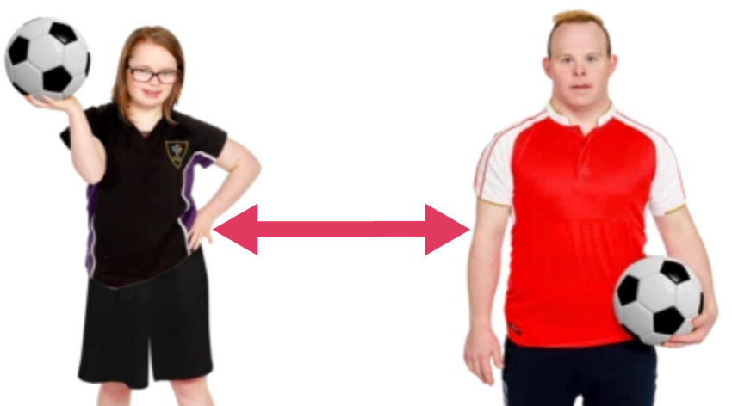 | You can exercise outside with one other person.  You can also exercise outside with the people who live in your house.

Do I have to wear a face covering if I go outside my home?

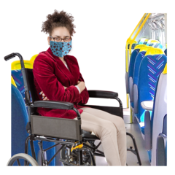 | Yes. You must wear a face covering when you need to go outside your home.
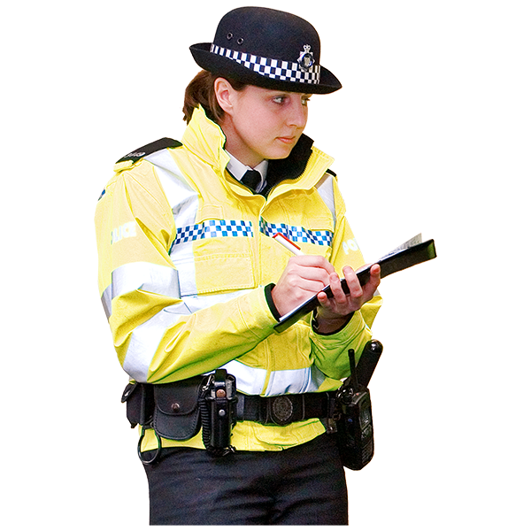 | From 23 July 2020, you will be fined for not wearing a face covering.
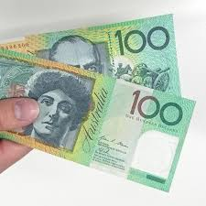 | The fine will be $200.
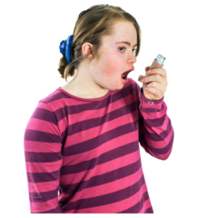 | Some people don’t have to wear a face covering. For example:  - People who have a medical reason like difficulty breathing
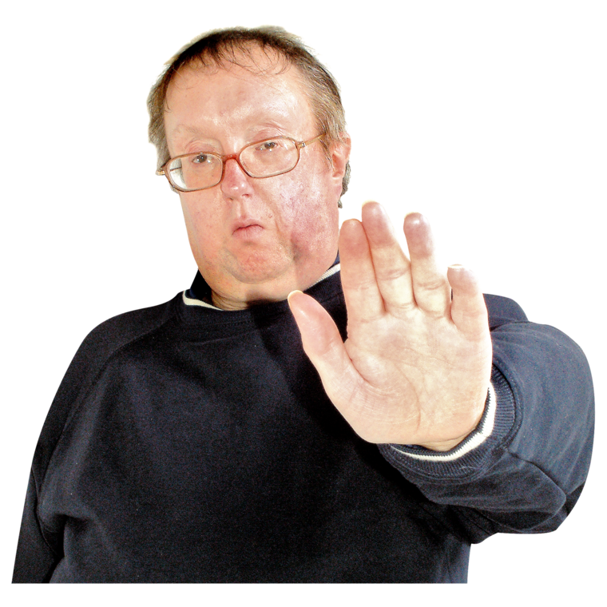 | - People who have conditions that make it difficult to wear a face covering
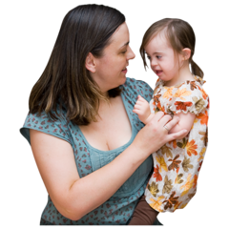 | - Children under 12 years of age
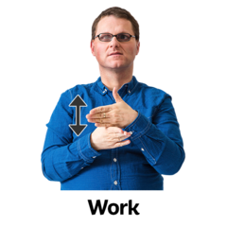 | - People who are deaf or hard of hearing, because wearing a face covering will make it hard for people to understand them.
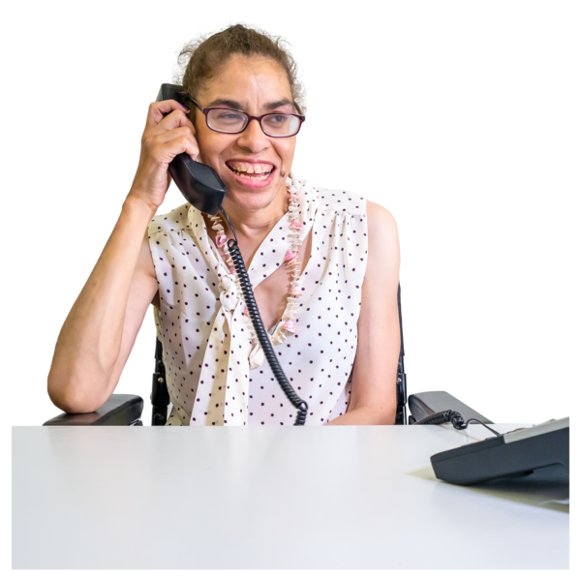 | - People who can’t wear a face covering because it would make it hard for them to work.
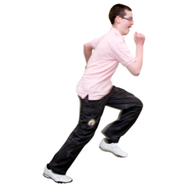 | - If you are doing lots of exercise and it’s hard to wear a face covering. For example, if you are running.  - But you must carry a face covering with you to wear once your exercise has finished.
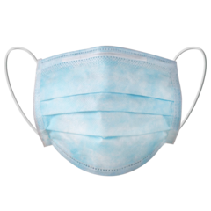 | You must carry your face covering at all times so that you can wear one when you can.
 | For more information about reasons for not wearing a face covering and how to wear and remove it, please visit https://www.dhhs.vic.gov.au/face-coverings-covid-19 <https://www.dhhs.vic.gov.au/face-coverings-covid-19>.

Can people visit me in my home?
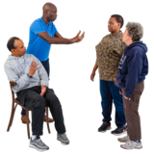 | No.  You can only have visitors in your home:  - to provide care and support  - to provide a service in your home, such as fixing your washing machine.

What about people living in disability accommodation?
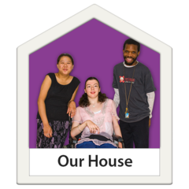 | Note: The rules for people living in disability accommodation are a bit different.  For more information please go to the Department of Health and Human Services website <https://www.dhhs.vic.gov.au/visiting-care-facilities-covid-19>.

Can I visit other people’s homes?
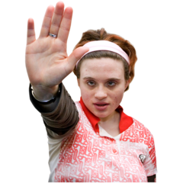 | No. You cannot visit other people’s homes except if you are:  - providing care to someone  - seeing your partner  providing a service, such as fixing a washing machine.
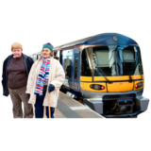  X | You should not travel.  You can only leave your home for the 4 reasons on page 6 and 7 of this book.

What places are open?
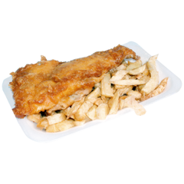 | Restaurants and cafes can serve takeaway and home delivery only.
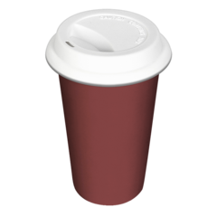 | Pubs, bars and clubs are closed, except to serve takeaway food or alcohol.
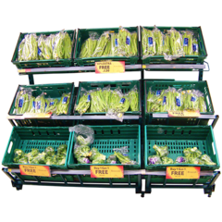 | Only market stalls that sell food and drinks can open.  People must keep 1.5 metres apart.
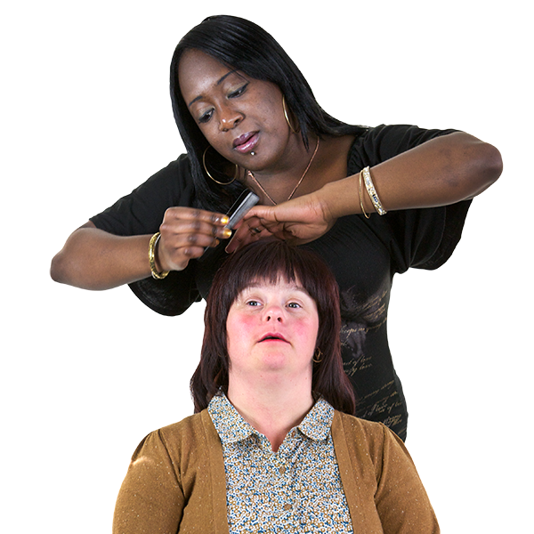 | Beauty and personal care services must close.  Only hairdressers and barbers can stay open.
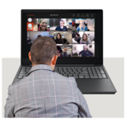 | Religious ceremonies and worship must happen over the internet.
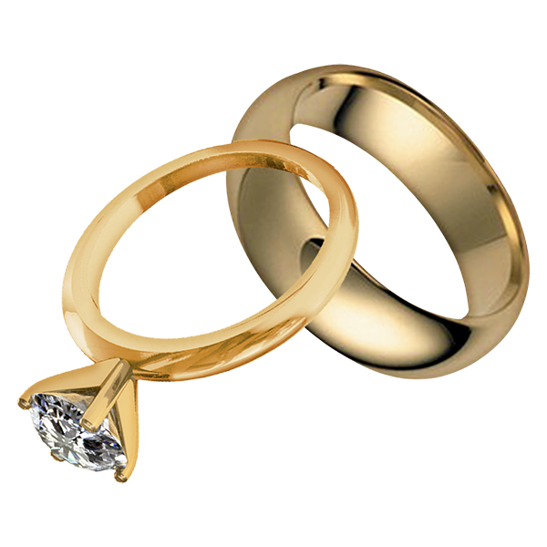 | Weddings are limited to 5 people. The couple getting married, the witnesses and the celebrant.  Stay 1.5 metres away from other people.
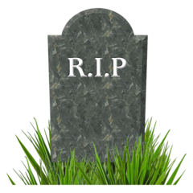 | Funerals are limited to 10 people.  Stay 1.5 metres away from other people.
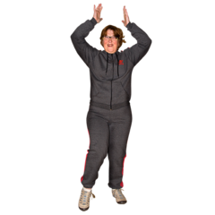 | Outdoor sport centres must close except for places where you can exercise with:  - one other person, plus a trainer if you have one  - people you live with.
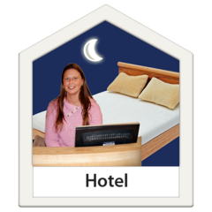 | Places to stay, like hotels, must close except for:  - emergency accommodation  - people who need to stay at a hotel for work.

Can students go back to school?
Most people are learning from home.
Some people are allowed to go back to school.
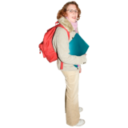 | People going back to school from 13 July are:  - Year 11 and year 12 students  - Year 10 students who are studying year 11 and year 12 subjects  - Year 10 students doing vocational studies. This is a different type of study where people learn job skills  - Students who go to Special Development Schools  - Students with a disability and those whose parents have to go to work.
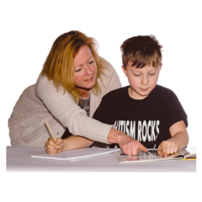 | All other students from Prep to year 10 are learning from home.
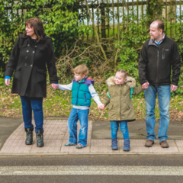 | Childcare and kindergartens are still open.
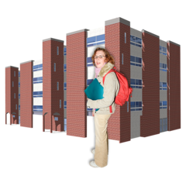 | People should only go to university or TAFE to study, if they cannot do this from home.
 | These changes to the rules will help slow the spread of coronavirus (COVID-19) and keep us safe.

What places are closed?

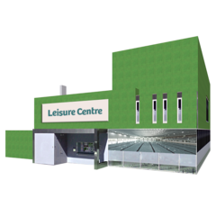  X | Indoor sport and exercise centres must close:  - gyms  - training centres  - pools
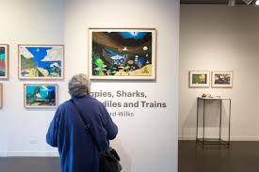  X | Other places in the community must close:  - galleries and museums  - theatres, arcades and casinos  - concert venues  - playgrounds and shared outdoor gym equipment
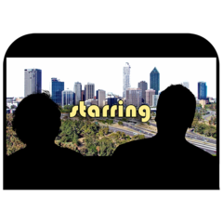  X | - indoor cinemas  - drive-in cinemas
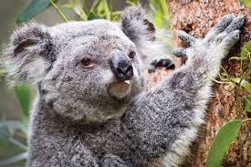  X | - parks and zoos  - aquariums
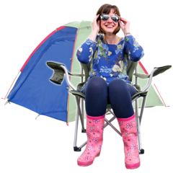  X | Camping facilities must close:  - caravan parks  - camping grounds  - school camps

Where can I find out more information?

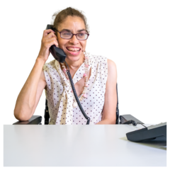 | You can call 1800 675 398
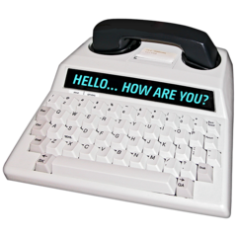 | For people who are Deaf, hard of hearing or speech impaired:  - call TTY on 133 677 then ask for 1800 675 398
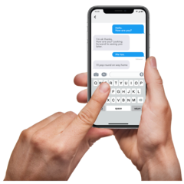 | - SMS relay number 0423 677 767
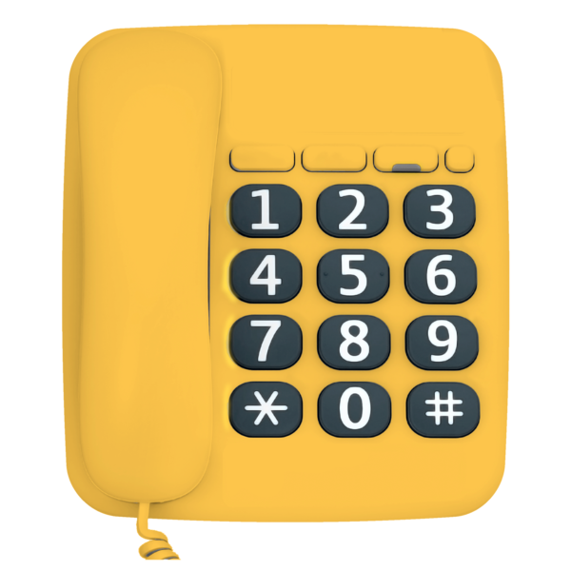 | - National Relay Service helpdesk 1800 555 660  or go to the National Relay Service website <www.relayservice.gov.au>
You can go to the Department of Health and Human Services (DHHS) website
<https://www.dhhs.vic.gov.au/information-people-disability-coronavirus-disease-covid-19>

To receive this document in another format phone 1300 880 043, using the National Relay Service 13 36 77 if required, or email Office for Disability <ofd@dhhs.vic.gov.au>
Authorised and published by the Victorian Government, 1 Treasury Place, Melbourne.
© State of Victoria, Department of Health and Human Services, July 2020.
Available at Department of Health and Human Services Coronavirus page <https://www.dhhs.vic.gov.au/coronavirus>

