Changes to coronavirus (COVID-19) restrictions from 19 July
Easy read information for people with disability
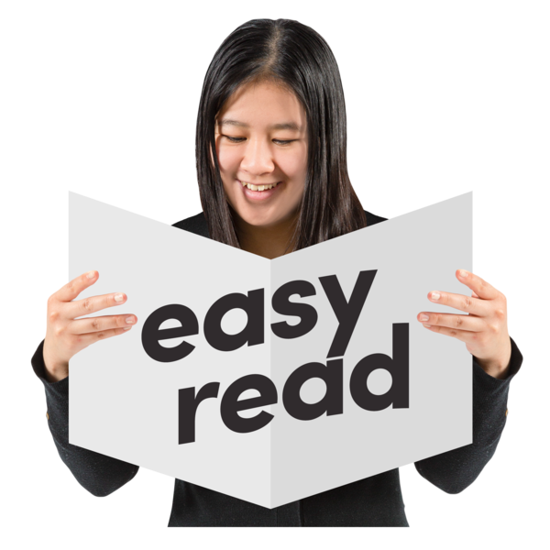

About this book
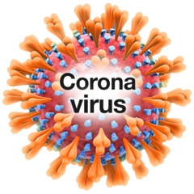 | Coronavirus has meant some changes to the way we do things.  Coronavirus is also called COVID-19.
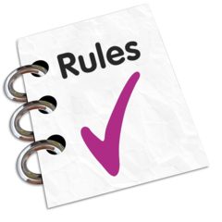 | The Victorian Government now has different rules for different parts of Victoria.
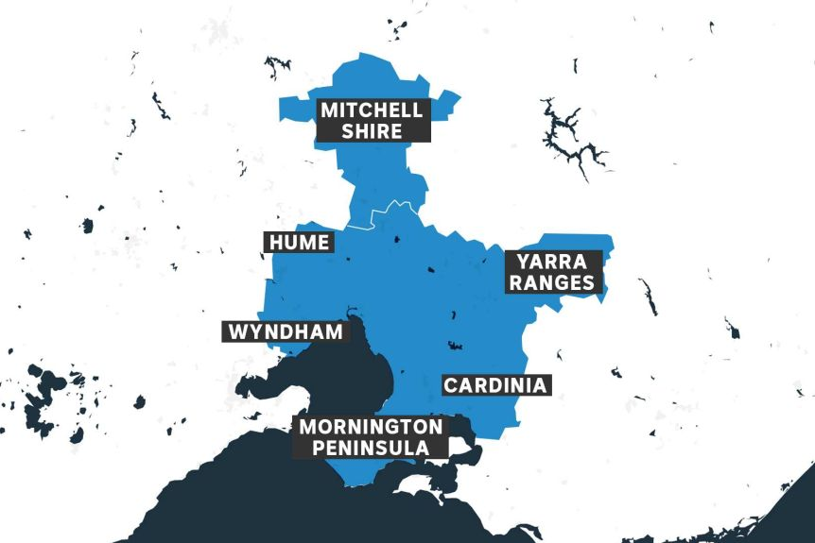 | The rules here are for people who live outside of the greater Melbourne area (all of Melbourne) and Mitchell Shire. The rules for people who live in the greater Melbourne area and Mitchell Shire are different.
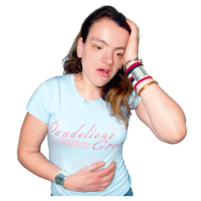 | This is because more people are sick with coronavirus (COVID-19) in greater Melbourne and Mitchell Shire.  That is why the Victorian Government has made different rules for different places.
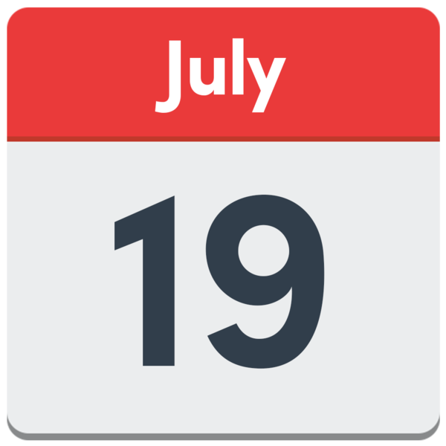 | This book will tell you how the rules have changed.  The rules changed from  19 July 2020.

What rules have not changed?
The Victorian Government has made some rules to keep people safe and healthy.

These rules have not changed.

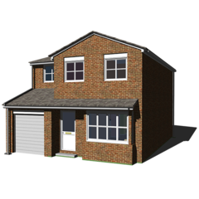 | These rules tell us to stay home if we are not well.
If you are not well, you should get tested for coronavirus (COVID-19).
You can go to a test site near your home. For testing information please go to the Department of Health and Human Services coronavirus website <https://www.dhhs.vic.gov.au/getting-tested-coronavirus-covid-19>.

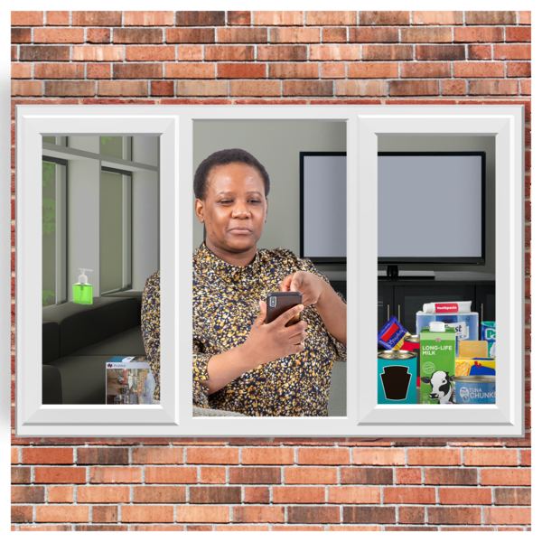 | You must return home after the test.  You must stay at home until you get your test result.
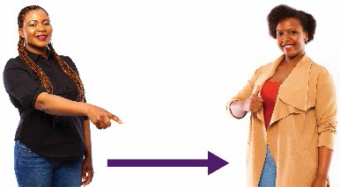 | The rules tell us to use physical distancing.  Physical distancing means you keep space between you and other people.  Stay 1.5 metres away from other people.  1.5 metres is two big steps away from someone.
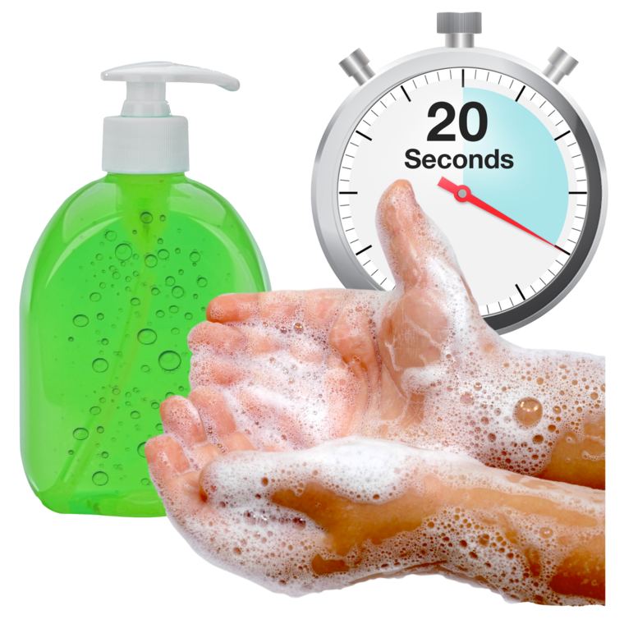 | The rules tell us to wash our hands with soap and water for at least 20 seconds:  - after you cough or sneeze  - before and after you eat  - after you use the toilet
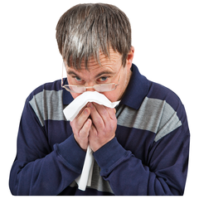 | The rules tell us to cover our mouth and nose with a tissue when we cough or sneeze.  If we don’t have a tissue, we should cough or sneeze into our elbow.
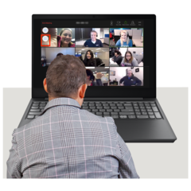 | The rules tell us to keep working from home if we can.  This will help stop you and others from getting coronavirus.

What are the rules for where I live?
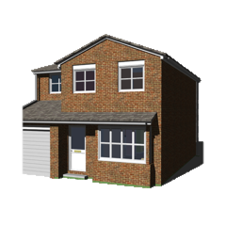 | Up to 5 people can come to your home at one time.  This is on top of people living in your home.
 | If you have visitors at your home, try to stay 1.5 metres away from people who don’t live with you.
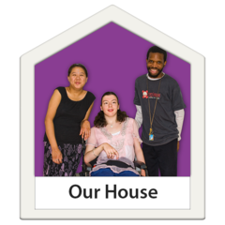 | Note: The rules for people living in disability accommodation are a bit different. For more information please go to the Department of Health and Human Services website <https://www.dhhs.vic.gov.au/visiting-care-facilities-covid-19>.
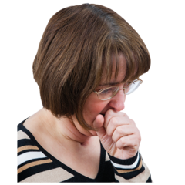 | If you are feeling unwell you should not visit anyone or have visitors at your home.
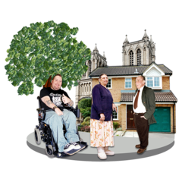 | Activities you can still do:  Go to cafes, restaurants, pubs and bars. Stay 1.5 metres away from other people.
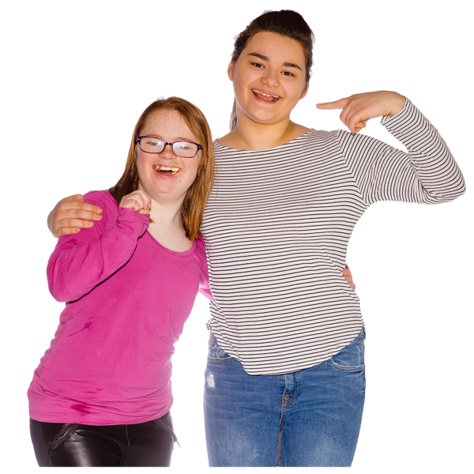 | Help or visit a friend or family member. Stay 1.5 metres away from other people.
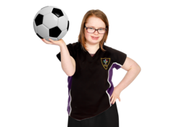 | Exercise in the gym or outside.  Stay 1.5 metres away from other people.

Do I have to wear a face covering if I go outside my home?
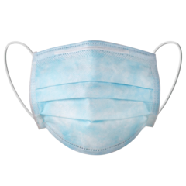 | No. You don’t have to wear a face covering if you need to go outside your home.  But if you are going to be near other people it is recommended that you wear a face covering.
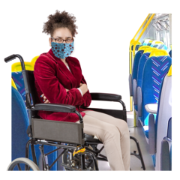  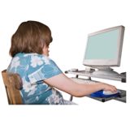  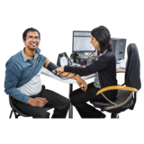 | You must wear a face covering if you travel to the greater Melbourne area or Mitchell Shire.  You can only visit the greater Melbourne area or Mitchell Shire for these reasons:  1. For work or study  You can only go to the greater Melbourne area or Mitchell Shire to work or study, if you cannot do this from home.  2. To give or receive care  You can only go to the greater Melbourne area or Mitchell Shire to:  - see a doctor  - care for someone else.

What you need to know about going to cafes and other places outside greater Melbourne and Mitchell Shire areas
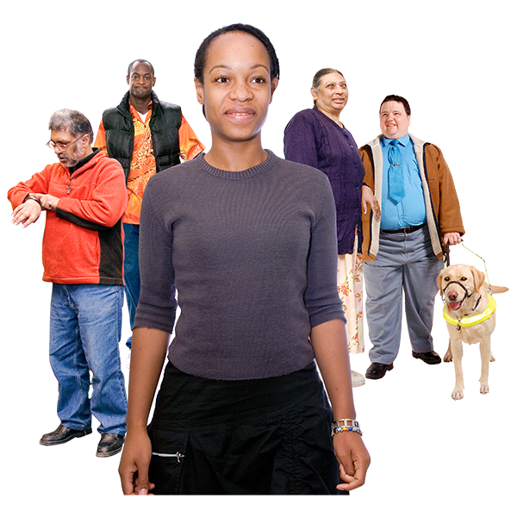  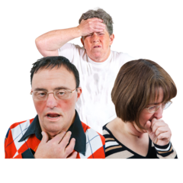 | You can go to public gatherings.  ‘Public gathering’ means a meeting with other people in the community.  Up to 10 people can meet in a public gathering.
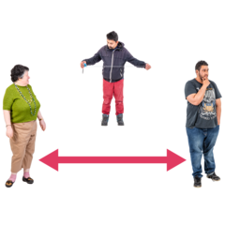 | If you leave your home, stay more than 1.5 metres away from other people.  1.5 metres is about 2 big steps away from someone.
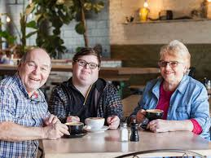 | You can eat and drink in a restaurant, cafe or bar.  Up to 20 people can be there at a time.  You can have 10 people in your group sitting together.  You can drink alcohol there. But you need to be sitting down.
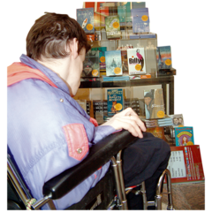 | You can go to:  - libraries  - community centres  - clubs.  Up to 20 people can be indoors at a time.
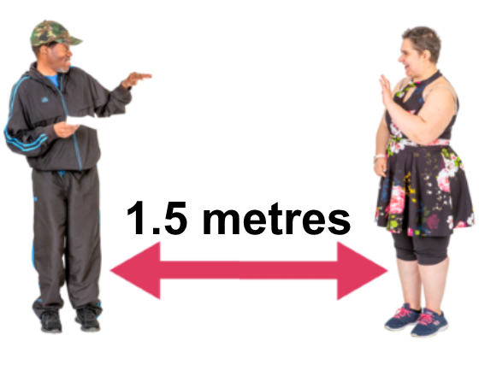 | Stay 1.5 metres away from other people.
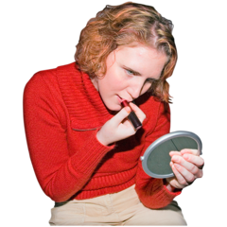 | You can go to shops for:  - beauty therapy  - waxing and nails  - tanning  - hair cut
- tattoos
- massages.
Up to 20 people can be in a shop.

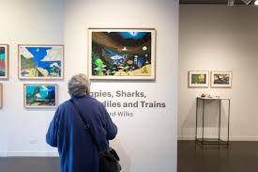 | You can go to:  - galleries and museums  - theatres  - concert venues.  Up to 20 people can be in a place at a time.
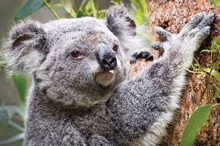 | You can go to:  - parks and zoos  - aquariums.  Up to 20 people can be in a space at a time.
 | Stay 1.5 metres away from other people.
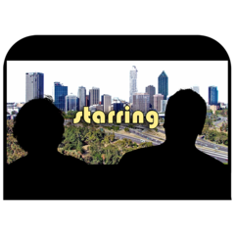 | You can go to:  - indoor cinemas  Up to 20 people can be there at a time.
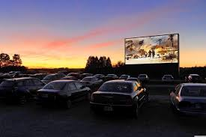 | You can go to:  - drive-in cinemas  Because people are in their cars, there are no restrictions on how many people can go to the drive-in cinema.  People cannot sit outside their car.
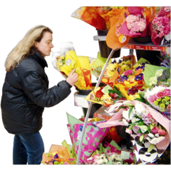 | You can go to markets for drinks and other non-food items.
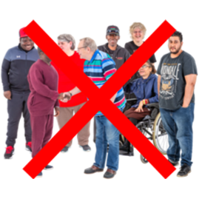 | You need to be careful when leaving your home.  Try to stay away from crowded areas.
 | If you leave your home, stay more than 1.5 metres away from other people.
There are lots of reasons you might leave your home.
To find out more, visit the Department of Health and Human Services website
< https://www.dhhs.vic.gov.au/restrictions-rest-victoria-covid-19>

What you need to know about visiting a friend or family member
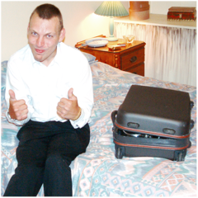 | You can stay overnight at a family or friend’s home outside the greater Melbourne area and Mitchell Shire.
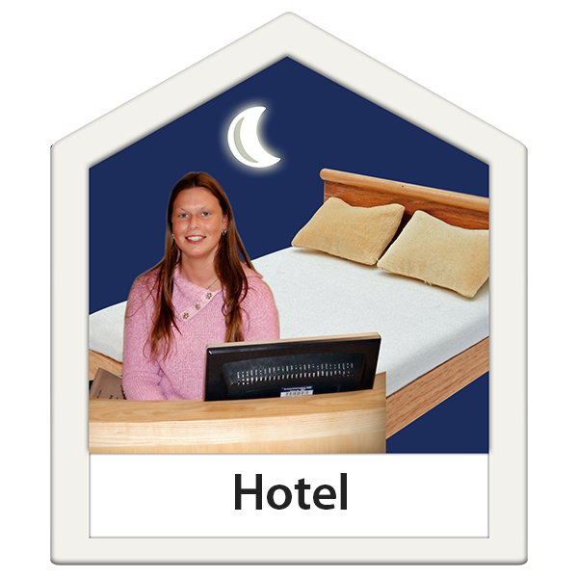 | You can stay:  - at someone’s home  - at a holiday home  - at a hotel
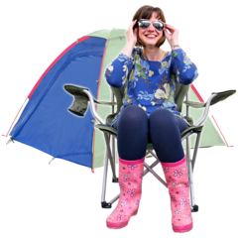 | You can go to  - caravan parks  - camping grounds  - school camps  - You can use shared kitchens and bathrooms.  Stay 1.5 metres away from people who are not traveling with you.
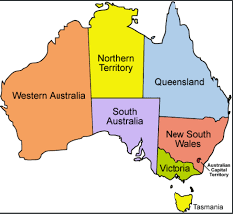  X | Some Australian states and territories won’t let people from Victoria travel there.  Some Australian states and territories will let people from Victoria travel there, but these people need to stay inside their hotel for 14 days when they arrive.
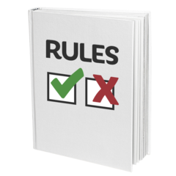 | If you must travel to another state or territory you will need a permit.  To find out what the rules are there you can go to the Australian Government website <https://www.interstatequarantine.org.au/state-and-territory-border-closures>.
 | Stay 1.5 metres away from people who are not traveling with you.
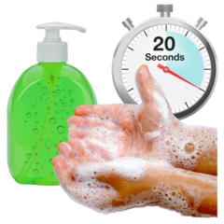 | Wash your hands often  Cough or sneeze into a tissue or your elbow.
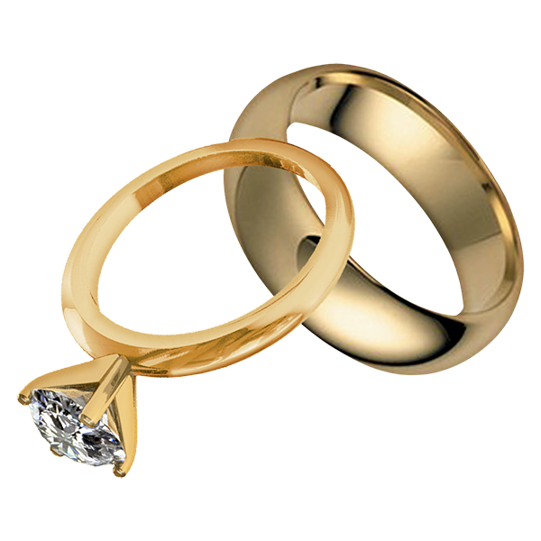 | You can still go to a wedding. Up to 20 people can go to a wedding.  If a wedding is held at someone’s home, up to 5 people can go to the wedding.  Stay 1.5 metres away from other people.
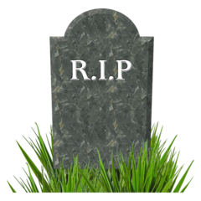 | Up to 50 people can go to a funeral.  If a funeral is held at someone’s home, up to 5 people can go to the funeral.  Stay 1.5 metres away from other people.
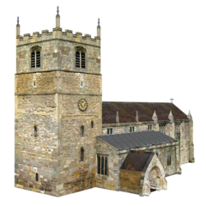 | Up to 20 people can go to a religious ceremony or gathering.  This might mean going to a mosque, church, temple or synagogue.  If the religious ceremony or gathering is held at someone’s home, up to people can go to the religious ceremony or gathering.  Stay 1.5 metres away from other people.
 | You should stay home if you feel sick.
To find out more, visit the Department of Health and Human Services website
< https://www.dhhs.vic.gov.au/social-gatherings-covid-19>

What you need to know about exercising and sport

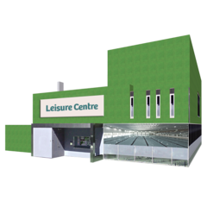 | You can go to indoor sport centres like:  - gyms  - health clubs  - dance studios.  Up to 20 people can be in the same space.  No more than 10 people in a group activity or class.
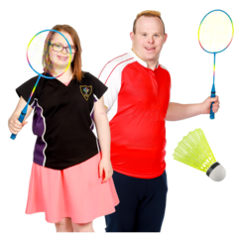 | You can do outside sport and exercise activities.  Up to 20 people can be in the same space and up to 10 people can be in a group or class.
 | Stay 1.5 metres away from other people.
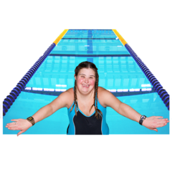 | You can go swimming inside and outside.  Up to 20 people can be in the pool.  You can use the change rooms and showers at the sport places.
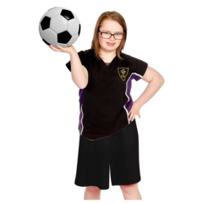 | People who are 18 years old or younger can do contact sport training and competition.  For example: footy, soccer, basketball, netball and other contact sports.
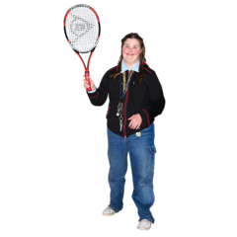 | You can do sports where you don’t touch other people. This includes sports like tennis.
 | Stay 1.5 metres away from other people.
 | Don’t play sport if you are feeling sick.

To find out more about exercising visit the
Department of Health and Human Services website
< https://www.dhhs.vic.gov.au/sport-and-exercise-restrictions-covid-19>

Can students go back to school?
Most people outside greater Melbourne and Mitchell Shire are back at school.
Some people are learning from home.
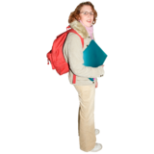 | People back at school are:  - Primary and high school students  - Students who go to Special Development Schools.
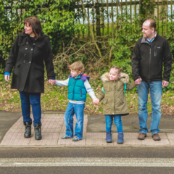 | Childcare and kindergartens are still open.
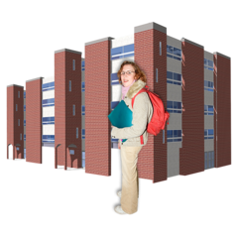 | People should only go to university or TAFE to study, if they cannot do this from home.

Where can I find out more information?
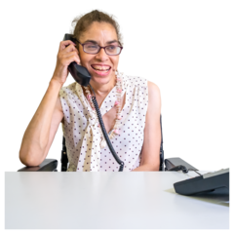 | You can call 1800 675 398
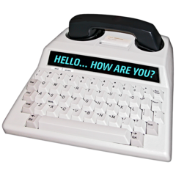 | For people who are Deaf, hard of hearing or speech impaired:  - call TTY on 133 677 then ask for 1800 675 398
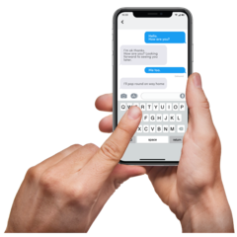 | - SMS relay number 0423 677 767
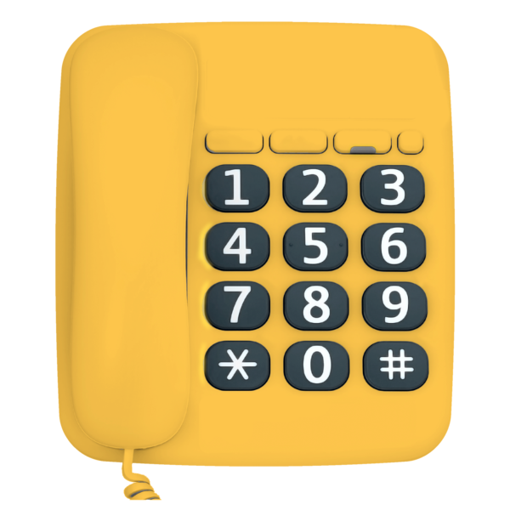 | - National Relay Service helpdesk 1800 555 660  or go to their website HYPERLINK "http://www.relayservice.gov.au/"www.relayservice.gov.au.
You can go to the Department of Health and Human Services (DHHS) website
<https://www.dhhs.vic.gov.au/information-people-disability-coronavirus-disease-covid-19>

To receive this document in another format phone 1300 880 043, using the National Relay Service 13 36 77 if required,
or email Office for Disability <ofd@dhhs.vic.gov.au>
Authorised and published by the Victorian Government, 1 Treasury Place, Melbourne.
© State of Victoria, Department of Health and Human Services, July 2020.
Available at Department of Health and Human Services Coronavirus page <https://www.dhhs.vic.gov.au/coronavirus>

