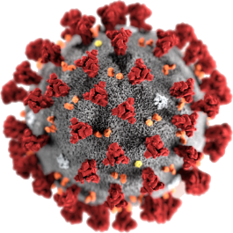

COVID - 19

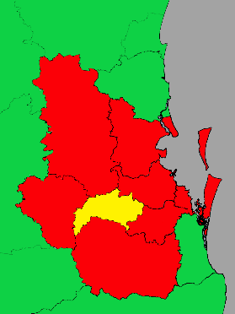

**Queensland. Ipswich**

**Did you go here?**

**16 August to 21 August**

30 August 2020. 12 noon.

There is more COVID - 19 in lots of places.

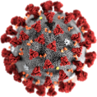

Queensland Health asks some people

to get a test.

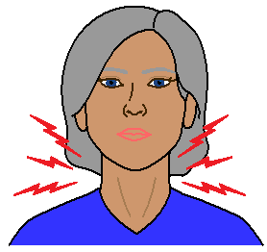

Do you have signs of COVID - 19?

Read page 12 for the signs.

You may only have a



* runny nose
* a bit of a scratchy throat.

**Did you go here?**

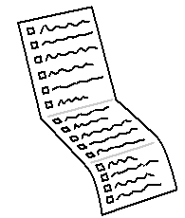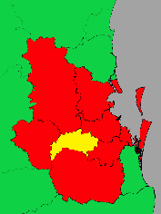

There is a list of places to check.

There are in the Ipswich area.



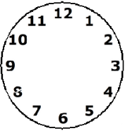Were you there at the

* same place
* at the same time?



You may need to get a test.

**Sunday 16 August**

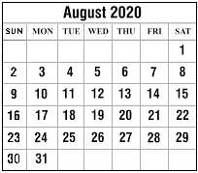

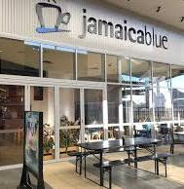Jamaica Blue coffee shop.

Ipswich.

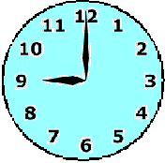

In the morning.

Riverlink Shopping Centre.

Ipswich.



In the morning.

The Reject Shop.

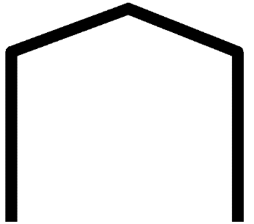

Ipswich



In the morning.

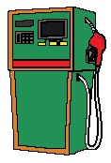7 - 11 Service Station.

Springfield.

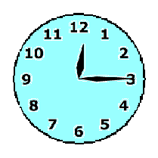

12:10 am to 12:15 pm.

Costco Bundamba self service fuel station

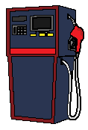

Bundamba



In the afternoon.

**Tuesday 18 August**



United Fuels.

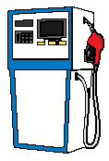

Springfield.



6:05 pm to 6:12 pm.

**Wednesday 19 August**





Officeworks.

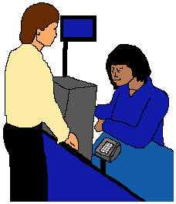

Ipswich.

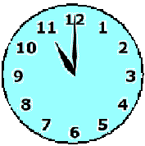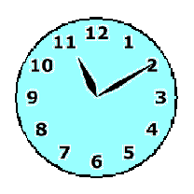

11 am to 11:10 am.



7 - 11. Springfield.

Springfield.

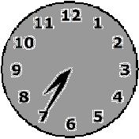

7:30 pm to 7:35 pm.

Ipswich Hospital. EDI.

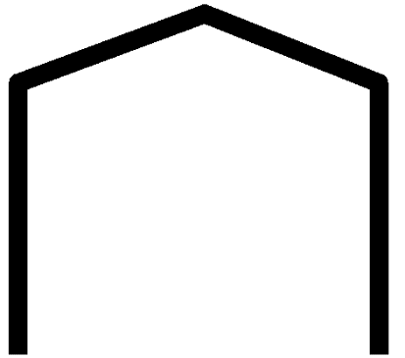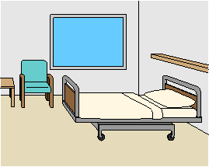

Ipswich.

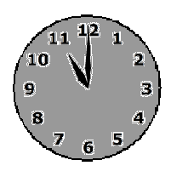

11 pm to midnight.

**Thursday 20 August**



Ipswich Hospital. EDI.

Ipswich.

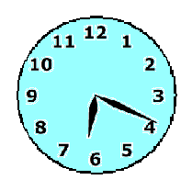

Midnight to 6:19 am.

USQ Campus Café.



Springfield.

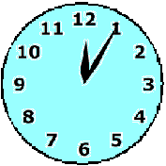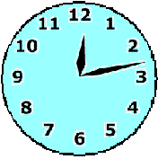

12:05 pm to 12:13 pm.

**Friday 21 August**



Orion Nail Bar.

Springfield.

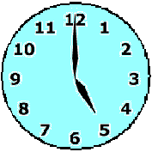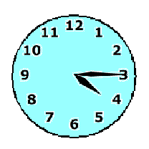

4:15 pm to 5 pm.

**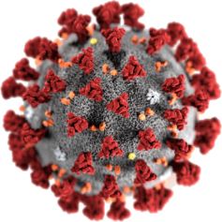****COVID - 19**



Look for the signs.

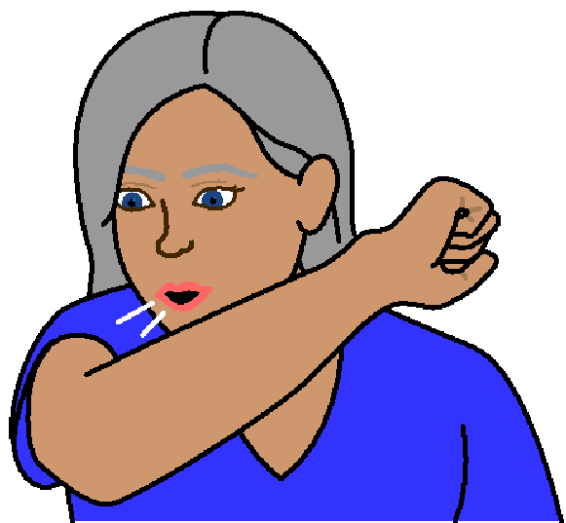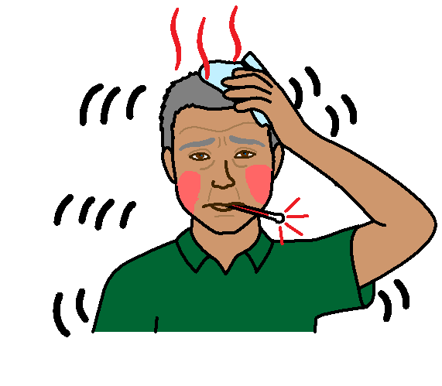



fever

red face

shivers

dry cough

hard to breathe

sore throat

**More information**

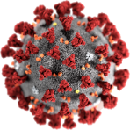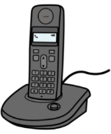

COVID - 19 information. Call 1800 020 080.

You can call at



* any time
* any day.

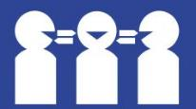Translations

Call 131 450

**Images**

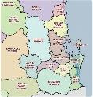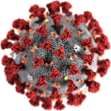We used images from

* Freepikps
* Map of SE Queensland.
* Mayer – Johnson
* 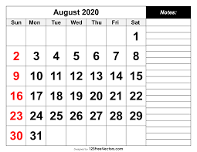Picto-Selector
* Photos of logos. Free photos.Google.com.
* PrintableCalendarTemplate

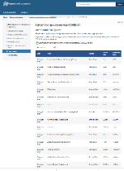This fact sheet is based on QLD Government Health alerts contact tracing. [www.qld.gov.au/health/conditions/health-alerts/coronavirus-covid-19/current-status/contact-tracing](http://www.qld.gov.au/health/conditions/health-alerts/coronavirus-covid-19/current-status/contact-tracing) at 29 August 2020 5:54 pm.

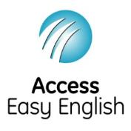

Access Easy English wrote the Easy English.

30 August 2020.