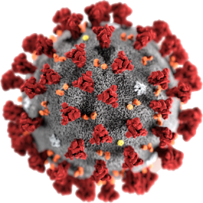

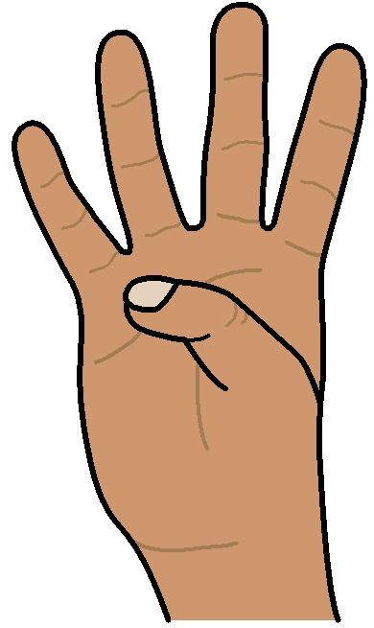COVID - 19

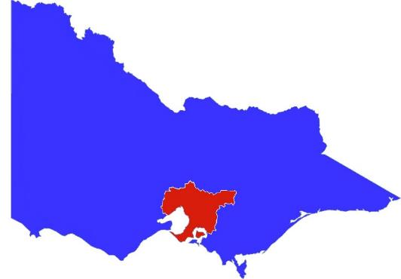

**Melbourne. Step 4**

**What can you do**

3 August 2020

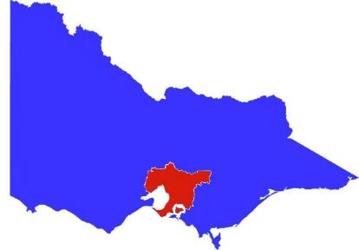There are new rules for Melbourne.

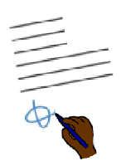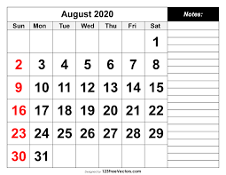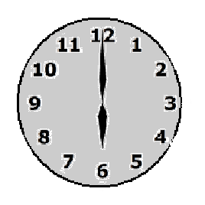

They started on Sunday 2 August 2020

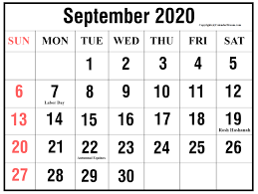

They will go for 6 weeks.

It is Sunday 13 September 2020.

It is for all these places in Melbourne.

* Banyule
* Bayside
* Boroondara
* Brimbank
* Cardinia
* Casey
* Darebin
* Frankston
* Glen Eira
* Greater Dandenong
* Hobsons Bay
* Hume.

**And**

It is for all these places in Melbourne.

* Kingston
* Knox
* Manningham
* Maribyrnong
* Maroondah
* Melbourne
* Melton
* Monash
* Moonee Valley
* Moreland
* Mornington Peninsula
* Nillumbik.

**And**

It is for all these places in Melbourne.

* Port Phillip
* Stonnington
* Whitehorse
* Whittlesea
* Wyndham
* Yarra
* Yarra Ranges.

Victoria is now in a

**State of Disaster**



Victoria has been in a State of Emergency.

It has been since March.



**Now** Victoria is in a State of Disaster.

It helps the government to do more. There will be more information about this later in the week.

**New Rules**

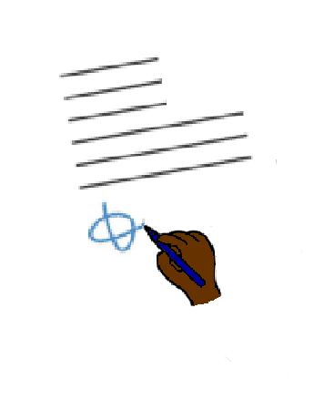

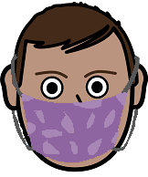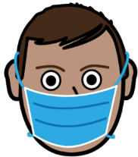

**You must wear a mask.**



**every time you go out.**

There is a $ 200 fine when you

do **not** wear a mask.

**But**



Some people do **not** need to wear a mask.

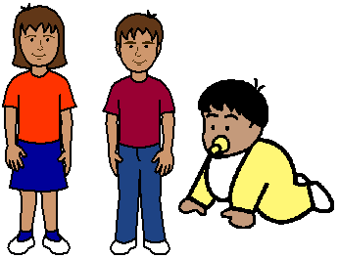Like

* children under 12
* children under 2 **must not** wear a mask
* 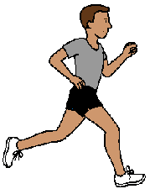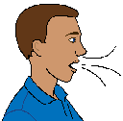it is hard for you to breathe
* your health makes it hard to wear a mask
* you are on a run.

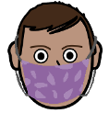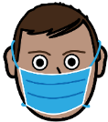Read more about masks.

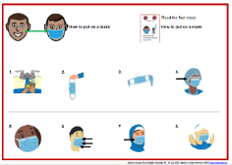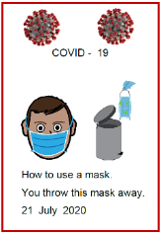

How to put on a mask. A 3 poster

How to use a mask. You throw the mask away.

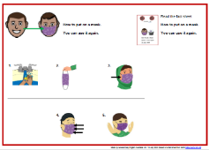

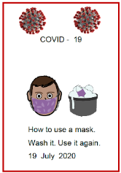How to use a mask again. A 3 poster.

How to use a mask. Wash it. Use it again.

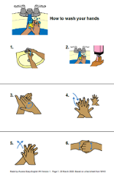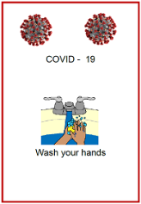How to wash your hands. A 3 poster.

Wash your hands.

**You must stay home**

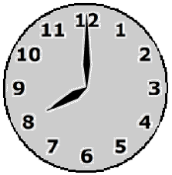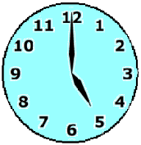

Every night

* after 8 pm

until

* 5 am.

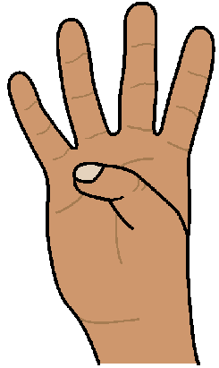

There are only 4 things you can go out for.

**But**

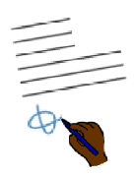

There are **new** rules for them.

****1.**To shop for food**. Like

* go to the supermarket
* 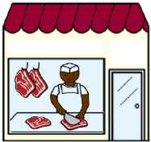to go to the meat shop
* to go to the bakery



* to pick up take away.

**But**

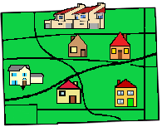

It must be near your home.

You can only go up to 5 km from your home.

**And**

Only **1 person** in your house can go.

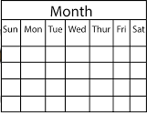

Your house can only go **1 time a day**.

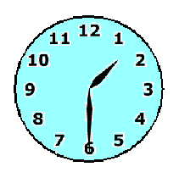

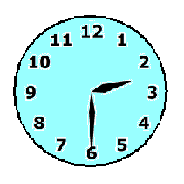It is for **1 hour** only.

Like from 1:30 pm to 2: 30 pm only.

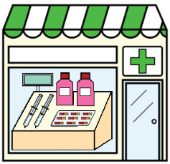

You can get other things you need.

Like pills at the chemist.

* 1. **To go to the doctor.**

**or**

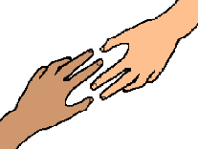

To care for some one.

Like

• your mum is old. You take food to your mum

• you help some one with a mental illness.

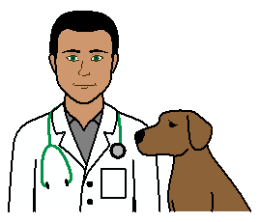

You can take a pet to the vet.

* 1. 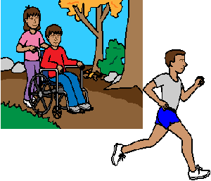**To do some exercise.**

You can go for a

* 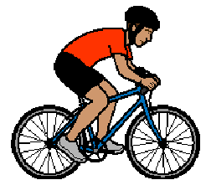walk
* or run
* bike ride.



It must be near your home.

It must be in your local area.

You can only go up to 5 km from your home.

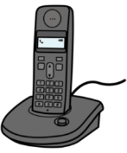

### There are people who can help work out 5 km from home. Call Ideas 1800 643 787

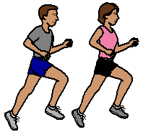You can go by your self.

**or**

You can go with 1 other person.



You can **not** play golf

You can **not** go fishing.



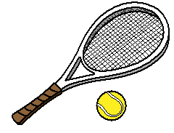You can **not** go out on a boat.

You can **not** play tennis.

* 1. **You can go to work.**

**But**



Only when you can **no**t work from home.



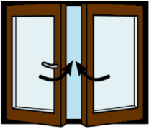There are new rules too.

There are many work places that need to **shut**.

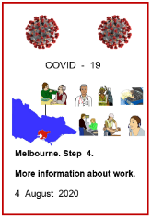Read Melbourne. Step 4.

More information about work. 4 August 2020.

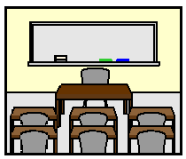**School. Study.**

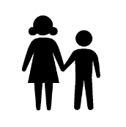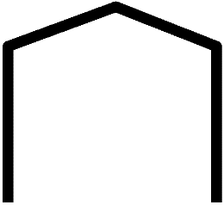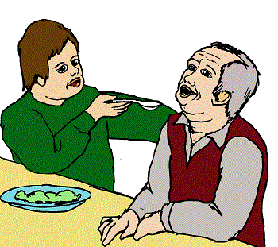

TAFE study is at home.

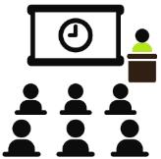

University study is at home.



On Wednesday 5 August 2020.



All children do school at home now.

Some children may need to go to school.

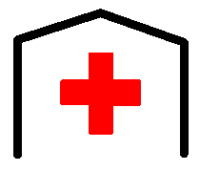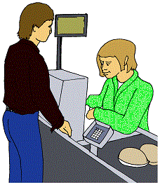

Like children

* of people that work in hospitals
* of people that work in supermarkets.

**or**



* who say school is the best place for them.

**Kinder. Child care.**

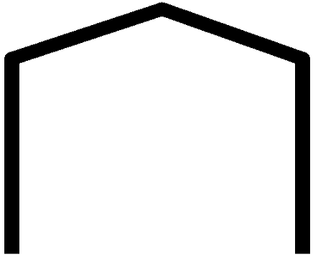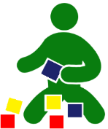

From Thursday 6 August 2020

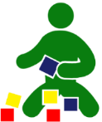

All kinders and child care in Melbourne

will be **shut**.

Some children may need to go.





Like children

* of people that work in hospitals
* of people that work in supermarkets.

**or**



* where child care is their safe place.

**Buses and trains**

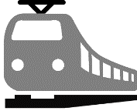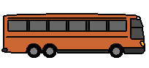

The Night Network will stop.



At night there will be less

* trains
* trams
* buses.

**Weddings**

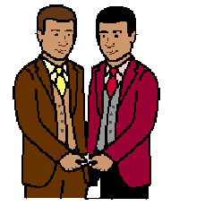

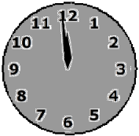



After Wednesday night 5 August 2020



there can be no weddings.

**Funerals**

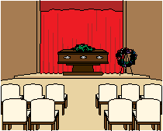

Only 10 people can go to the service.

**More information**

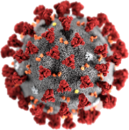

COVID - 19 information.

Call 1800 020 080.

You can call at



* 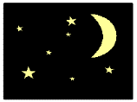any time
* any day.

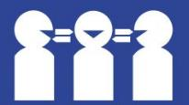Translations

Call 131 450

**Images**

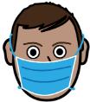We have used images from

* EasyOnTheI
* Freepikpsd
* InspiredServices
* Mayer-Johnson
* Picto-Selector
* PrintableCalendarTemplate
* 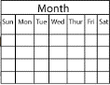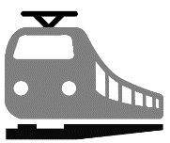SocialBuzz
* TheNounProject.

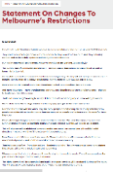This fact sheet is based on the Vic Government Premiers Press Release 2 August 2020.

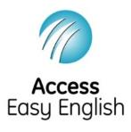Access Easy English wrote the Easy English. Number 2. Updated 4 August 2020.