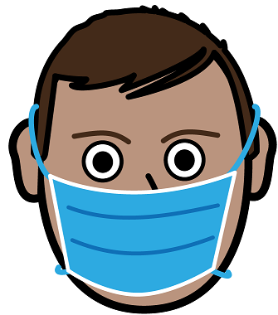

**Use a mask**

The Victorian Premier says it is a good idea.

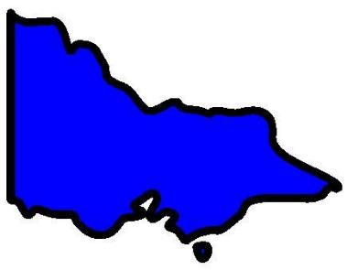

It is for all of

* Melbourne
* Mitchell Shire.

All these places are in Stage 3 shutdown.

Wear a mask when there is **no** space. Like



* at the shops

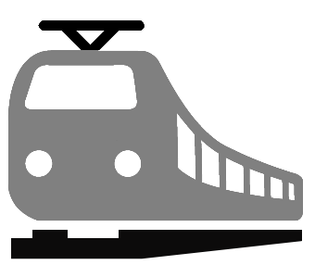

* 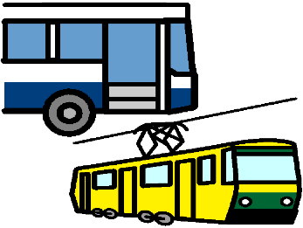on the train
* on the bus
* on the tram.

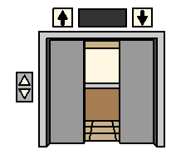Other places may be

* in a lift
* on stairs
* 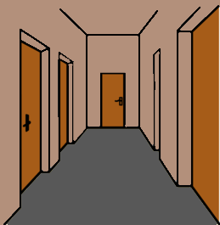in a shared hallway with other families.

Like in the housing towers.

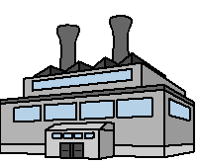

It may also be at your work.

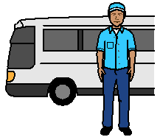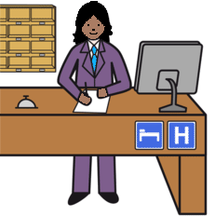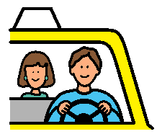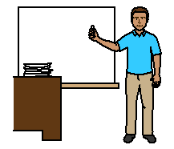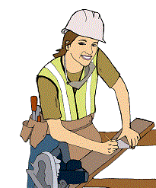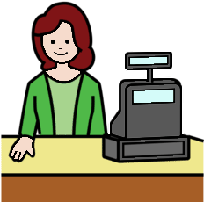

Based on the Victorian Premiers Press release 10 July 2020. Developed by Access Easy English. 12 July 2020. Australia

Images from EasyOnTheI, Inspired Services, Mayer-Johnson, Picto-Selector, TheNounProject