Coronavirus disease (COVID-19)

Looking after yourself if you are a person with disability
– Easy English

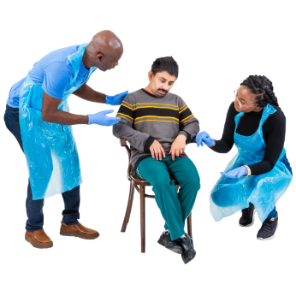
Self-isolation helps slow the spread of coronavirus and can save lives.

Self-isolation means staying in your home for at least 2 weeks. Sometimes it is longer.

Self-isolation can be hard for lots of people.

It is very normal to feel worried about your situation.

You should try to do things to stay healthy when in self-isolation.

How to stay healthy and well when you are in self-isolation

Follow the advice from the Department of Health and Human Services www.dhhs.vic.gov.au/coronavirus

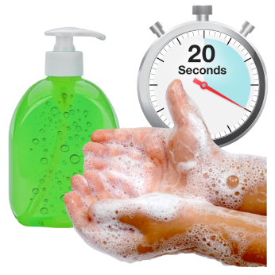
Wash your hands often with soap and running water, for at least 20 seconds.

If you need help, make sure your carer knows about how long you need to wash your hands.

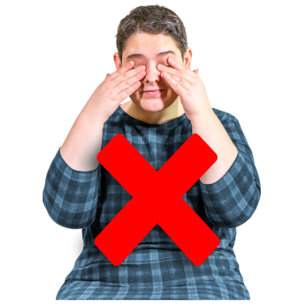
Try not to touch your eyes, nose or mouth.

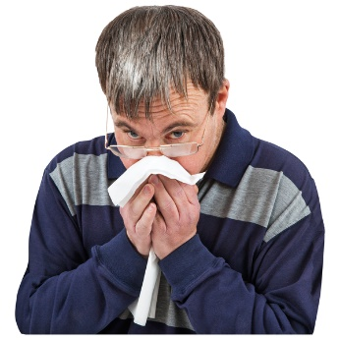
Cover your nose and mouth with a tissue when you cough or sneeze.

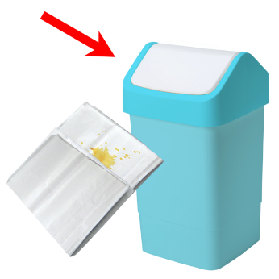
Throw away the tissue in a bin immediately.

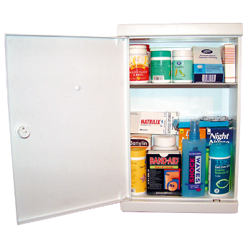
If you take medication make sure you have enough supply.

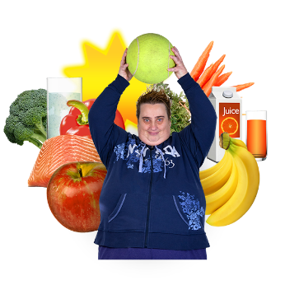
Continue healthy habits: exercise, drink water, get plenty of sleep.

Exercise is a good way to stay healthy. If you can, do some exercise at home like dancing, aerobics, stretching or yoga.
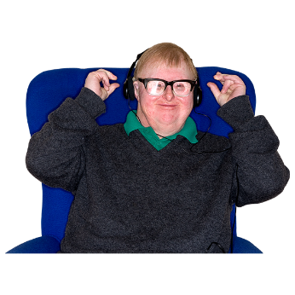
Plan activities that help you feel calm and safe. These might be things like meditation, breathing exercises, or listening to relaxing music.

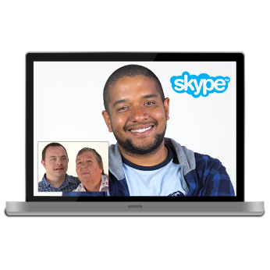
Reach out to the people you trust, like friends, family, neighbours, workmates via phone, e-mail or face-to-face video conferencing (eg, Facetime, Facebook video, Whatsapp video).

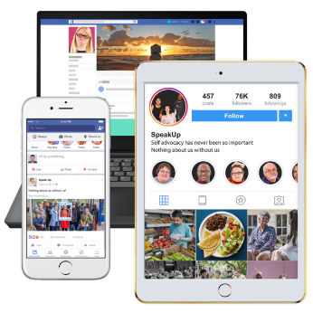
Share how you feel and try linking with people who are in a similar situation as you. If possible, join an online forum, social media group or other online community for support.

You may feel overwhelmed and stressed during this time. It is important to remind yourself that this is normal and will pass.

Create a plan about things you could do or say to yourself during these times.

To access general medical advice

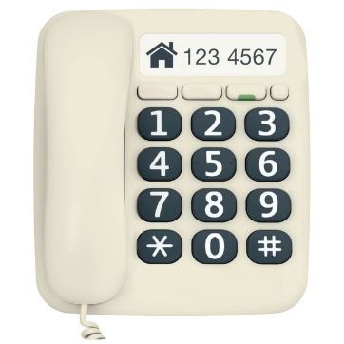
Phone your doctor or the Coronavirus hotline – 1800 675 398 – if you need medical attention.

NURSE-ON-CALL 1300 60 60 from anywhere in Victoria to talk to a nurse at any time.

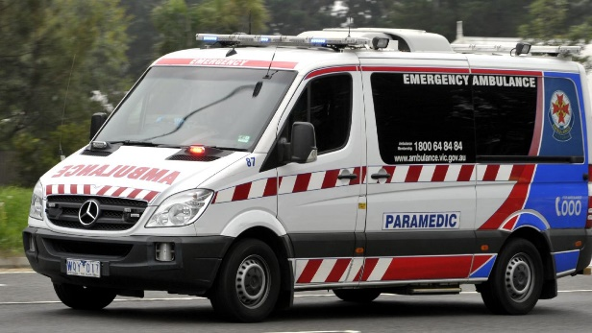
If it is an emergency you should call 000. Tell them you are in self-isolation for COVID-19 and explain your situation.

What to do if you need additional support?
If you have a NDIS package and need more support, contact the NDIA on 1800 800 110 to request a plan review for additional supports.

Contact your support coordinator or regular service providers to see what additional support they can provide.

If you are not an NDIS participant and receiving support, contact the support service directly.

Where can I find out more information?
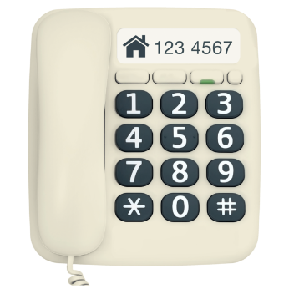
The Coronavirus hotline – 1800 675 398.

The Department of Health and Human Services provides regular advice and updates about all aspects of COVID 19 https://www.dhhs.vic.gov.au/coronavirus-covid-19-daily-update

For people with NDIS supports https://www.ndis.gov.au/understanding/ndis-and-other-government-services/ndis-and-disaster-response

For people with disability get updates from https://pwd.org.au/information-about-covid-19-or-coronavirus/

If you need an advocate DARU – Disability Advocacy Resource Unit https://www.daru.org.au/find-an-advocate

Beyond Blue https://www.beyondblue.org.au/get-support/get-immediate-support

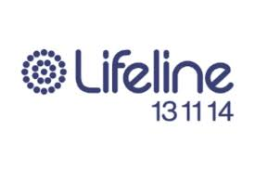
Lifeline Australia 13 11 14 www.lifeline.org.au

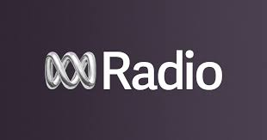
Listen to the radio and television for updates. ABC local radio is the official emergency broadcaster for Victoria.

