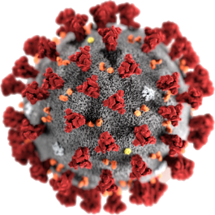

COVID - 19

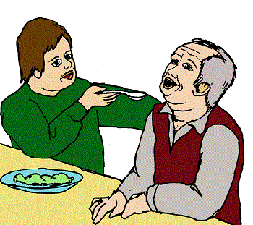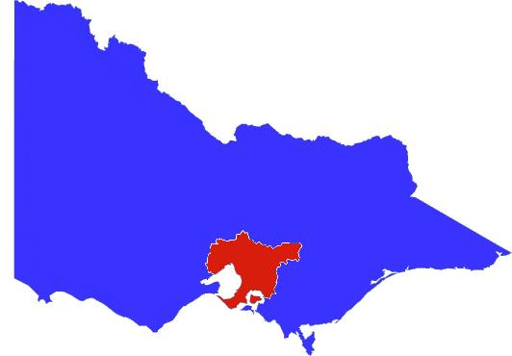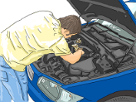

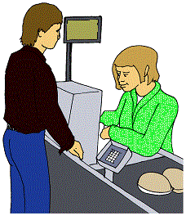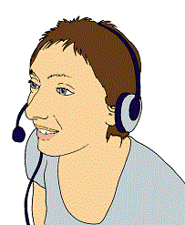

**Melbourne. Step 4. Book 1.**

**More information about work.**

5 August 2020

Victoria is now in a

**State of Disaster**



Victoria has been in a State of Emergency.

It has been since March.



**Now** Victoria is in a State of Disaster.

It helps the government to do more. There will be more information about this later in the week.

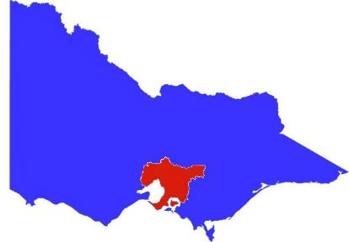There are new rules for Melbourne.

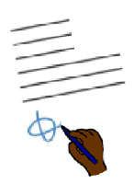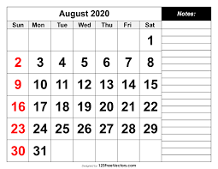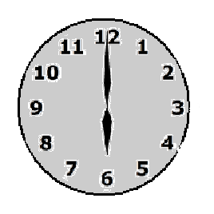

They started on Sunday 2 August 2020

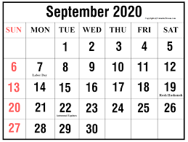

They will go for 6 weeks.

It is Sunday 13 September 2020.

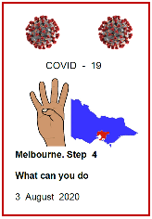Read **Melbourne Step 4**

**What can you do. 3 August 2020**

****There are lots of new rules for work.





Talk to your own work place about this.

It also means you may **not** be able to

* buy some things
* go to some things.

The work place rules start at midnight on

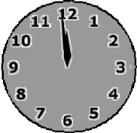

Wednesday 5 August 2020.

They will go for 6 weeks.



It is Wednesday 16 September 2020.

1. 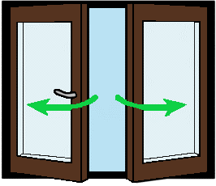**Some places stay open**

These are some of the places still open.

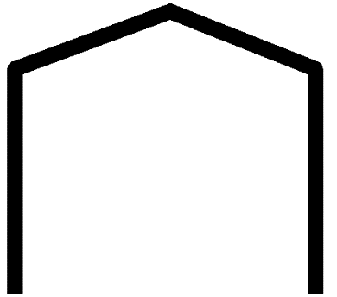

****Supermarkets are open.

Grocery stores are open.

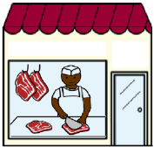

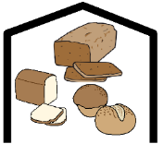Other food shops open are

* meat shop
* 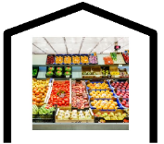bread shop
* fruit shop.

**and**

* 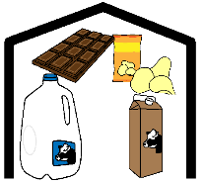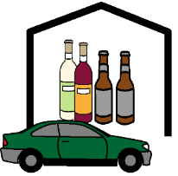beer and wine shops.
* convenience Shop. Like a milk bar.

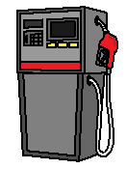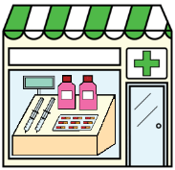Other places open are

* petrol stations
* 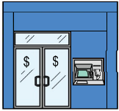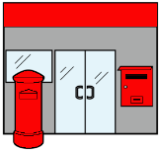chemists
* post offices
* banks

**and**

* places that sell baby things.

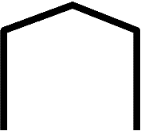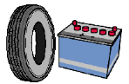

* car parts shops for broken parts.

Like new tyre.

Some services are open. Like

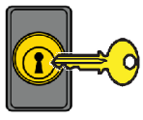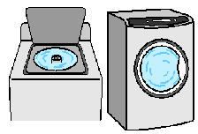

* lock smith. They can fix your door locks.
* laundries
* dry cleaners.



All staff working to stop COVID - 19 stay open.

Like staff

* in hospitals
* testing for COVID - 19
* doing study on COVID - 19
* who clean where COVID - 19 is found

**and**

* people in government.



They help plan what we need to do

* people who tell us the news.

Other medical staff can work. Like

* your local doctor
* physiotherapist.

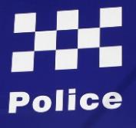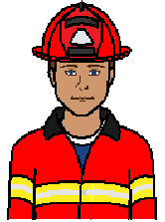All emergency services stay open. Like

* police
* ambulance
* fire stations.

The army are helping the police too.

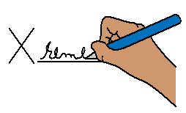You need a signed paper to go to work.

Your boss also signs the paper.

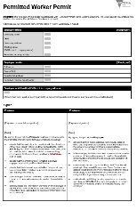Your boss gives you the paper.

It is called a **Permitted Work Permit.**

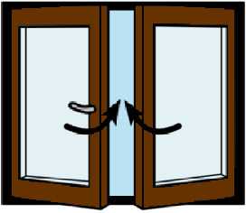**There are many places shut**

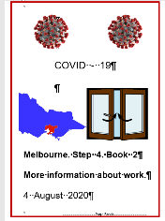Read this in **Book 2**

**More information about work.**



**There are many places only some people can work**

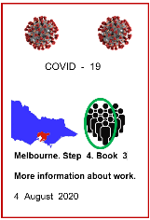Read this in **Book 3**

**More information about work.**

**More information**

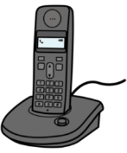

COVID - 19 information. Call 1800 020 080.

You can call at



* any time
* any day.

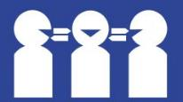Translations

Call 131 450

**Images**

We have used images from

* Freepikps
* 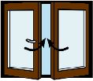InspiredServices
* Mayer-Johnson
* Picto-Selector
* ****PrintableCalendarTemplate
* TheNounProject.

## This fact sheet is based on the Victorian Premiers Press Release 3 August 2020 and Permitted Work Permit. 5 August 2020.

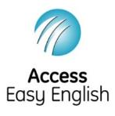Access Easy English wrote the Easy English.

5 August 2020.