Zoom Meetings

Zoom is a program that allows you to run or join a meeting online.
Zoom can be used on a computer, smart phone or tablet.

The following pages will explain in steps how to download Zoom, create an account, host a meeting and join a meeting.

Table of Contents
Downloading Zoom 2
How to Download Zoom on a desktop or laptop computer 2
How to Download Zoom on an iPhone or iPad 3
How to Download Zoom on an Android Smartphone or Tablet 4
Creating a Zoom account 5
Creating a Zoom Meeting 6
Joining a Zoom Meeting 9
Joining a Zoom Meeting using the internet 9
Joining a Zoom Meeting by phone 10

Downloading Zoom

How to Download Zoom on a desktop or laptop computer

Before you can Zoom the first time on your computer, you need to download the Zoom meeting application (app).
You can download the meeting app from the Zoom website at https://zoom.us/download
To download zoom for a computer, click on the ‘Download’ button under the text ‘Zoom Client for Meetings.’
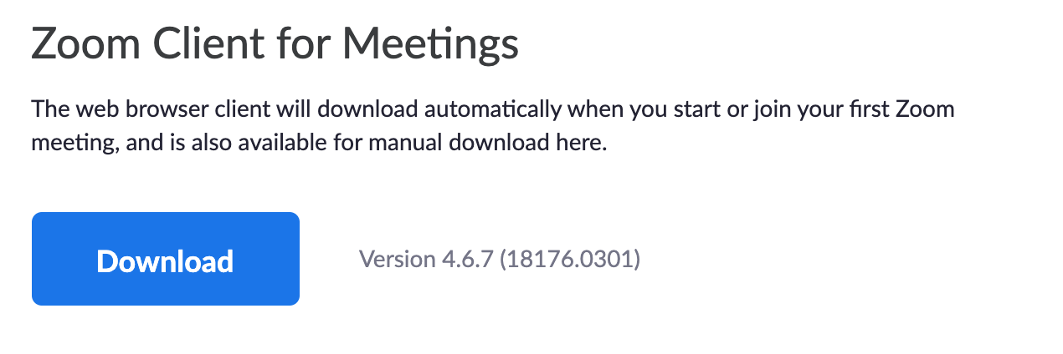
The application will download automatically.

Once the download is complete, another application to install Zoom will automatically open on your computer. Follow the steps to install the application.
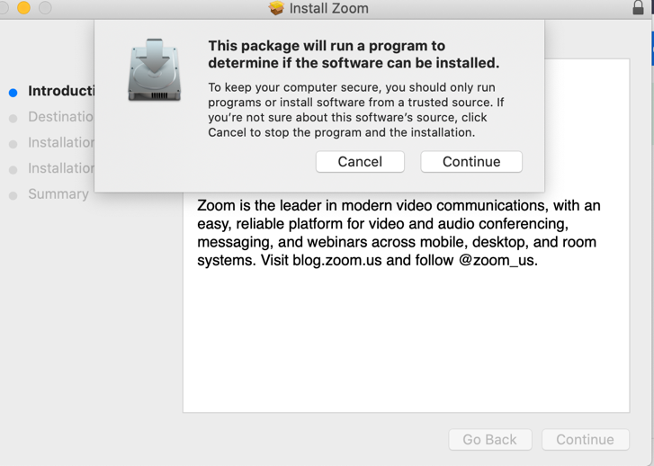
Once downloaded, Zoom will appear as a blue icon in your applications folder.

How to Download Zoom on an iPhone or iPad

Before you can use Zoom the first time on your iPhone or iPad, you need to download the Zoom meeting application (app).
You can download the meeting app from the Zoom website at https://zoom.us/download
To download zoom on an iPhone or iPad click on the ‘Download in App Store’ under the heading ‘Zoom Mobile Apps.’

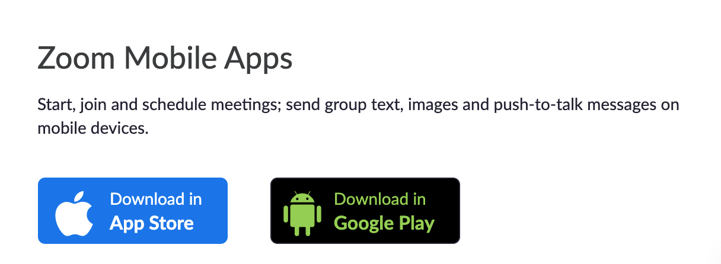

This button will take you to the app store, where you will need to click the button that says ‘Get.’

If you have already downloaded Zoom, the button will say ‘Open.’

Once downloaded, Zoom will appear as a blue icon on the home page of your iPhone or iPad.

How to Download Zoom on an Android Smartphone or Tablet

Before you can use Zoom the first time on a smart phone or tablet that is not apple branded you need to download the Zoom meeting application (app).
You can download the meeting app from the Zoom website at https://zoom.us/download
To download zoom on your smart phone or tablet click on the ‘Download in Google Play’ under the heading ‘Zoom Mobile Apps.’

This button will take you to the ‘Zoom Cloud Meetings’ App on the Google Play store, where you will need to click the green button that says ‘Install.’

Once downloaded, Zoom will appear as a blue icon on the home page of your smartphone or tablet.

Creating a Zoom account

Before you can organise or host a meeting with Zoom you need to create an account.

To create an account, go to https://zoom.us/

Click on the button that says ‘Sign up. It’s free’ in the top right-hand corner.

On the next page you will need to type your email, and then follow the steps on the screen.
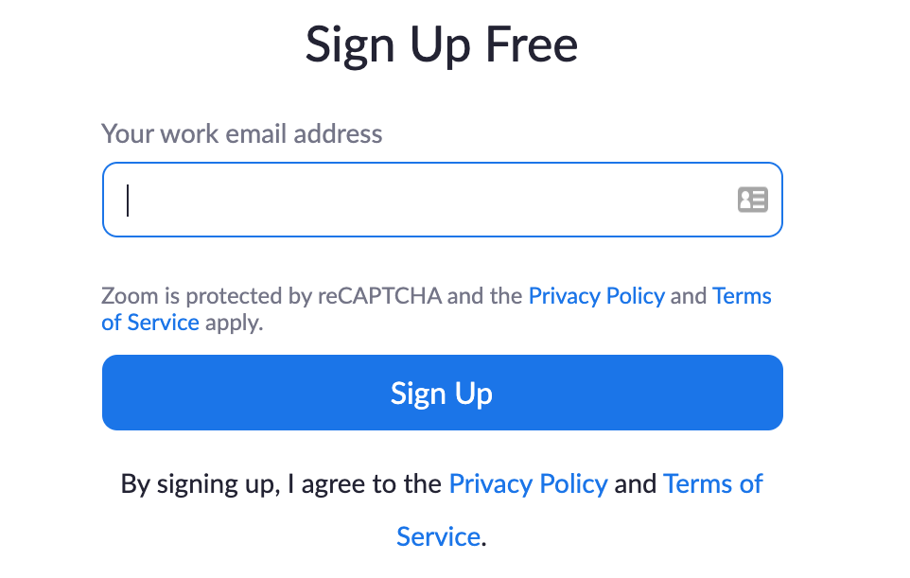

Creating a Zoom Meeting

To create a Zoom meeting, you need to

Open the Zoom app on your computer, tablet or mobile phone.

Click the button that says sign in.

Type in your details and sign into your account.
Once signed in, click on the small + button.

A window will appear with options to schedule a meeting.
Choose the date and time you would like the meeting to be held at
Under the heading ‘Password, untick the require meeting password box.

Under the heading ‘Video,’ choose ‘on’ for Host and Participants
Under the heading ‘Audio,’ choose ‘Telephone and Computer Audio.’
This will allow people to join by computer, tablet or phone.

Under the heading ‘Calendar’ choose iCal, Google Calendar or Outlook depending on which type of email you use.
- If you use an apple email, choose iCal.
- If you use a Gmail, choose Google Calendar.
- If you use Outlook or Hotmail, choose Outlook.

Under the heading ‘advanced’ options, you can choose any of the options, or leave them blank.
Once the form is complete, click ‘schedule.’

The meeting will now appear on both your zoom account and your email calender.

To invite people to the meeting, go to your email calender and click on the Zoom meeting on the date it was scheduled for.
You can then add people to the meeting by typing in their email in the ‘To:’ section.
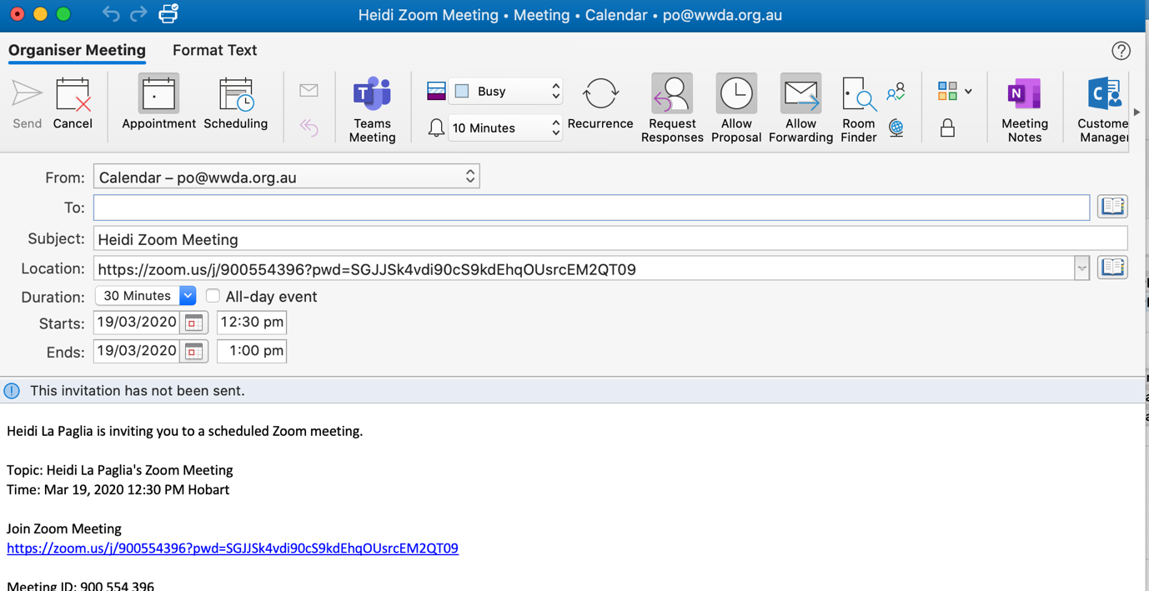

Once you have added in the emails of the people you want to invite, click ‘Send’ in the top right-hand corner.
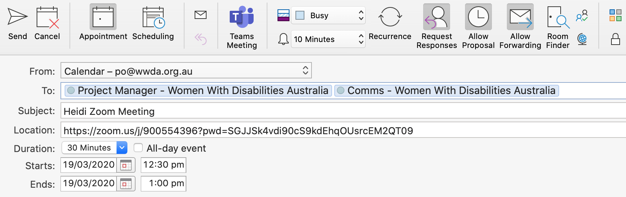

Joining a Zoom Meeting

Joining a Zoom Meeting using the internet

To join a zoom meeting using the internet, you need to

Open the email or event invitation you received with the zoom meeting details.
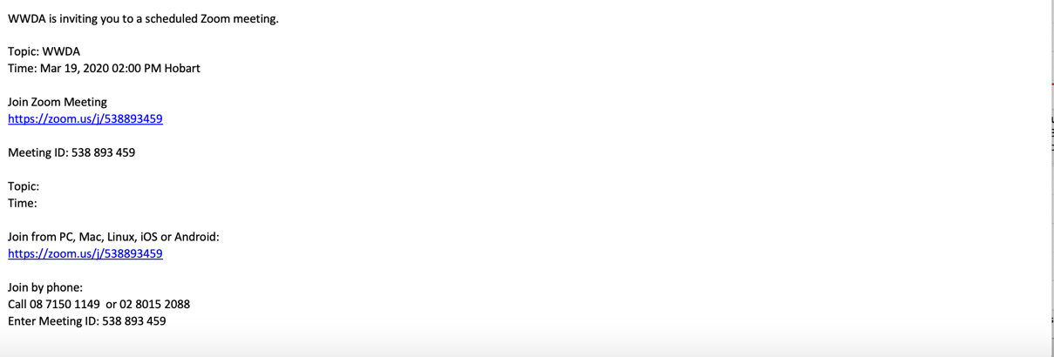
Then click on the link under the text ‘Join Zoom Meeting.’

This will automatically open the meeting in the zoom application.
If this does not work, you can
Copy or write down the number next to the text ‘Meeting ID.’
Open the Zoom app on your computer, tablet or mobile phone.

Click the button that says, ‘Join a Meeting.’

Paste or type in the meeting ID number.

This will automatically open the meeting in the zoom application.

Joining a Zoom Meeting by phone

To join a zoom meeting using the internet, you need to

Open the email or event invitation you received with the zoom meeting details.
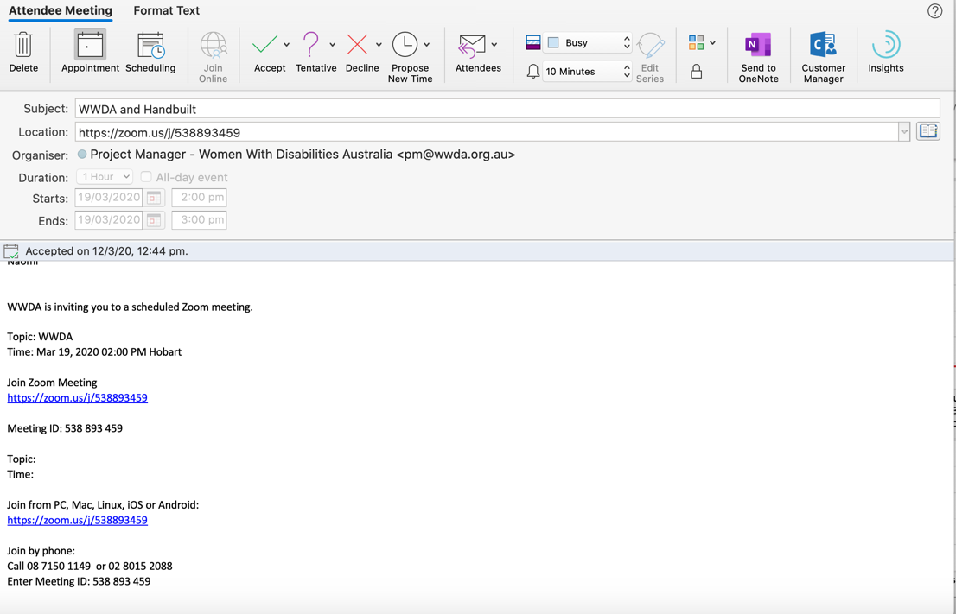
Copy or write down the numbers under the text ‘Join by phone.’

Use your phone to call the number next to ‘Call.’
Then enter the Meeting ID number.

More Information

For more information on how to use Zoom meetings, go to the Zoom website at https://zoom.us/

