Social bubbles
Frequently asked questions for carers

I am a single person, caring for someone with a profound disability or illness over the age of 18. Can I form a social bubble with someone?
Yes, you can still form a social bubble if you do not live with any other adults, but you should consider if this will put the person you are caring for at risk. Professional respite care for people with complex needs is allowed.

I am a carer, can I visit my bubble while the person I care for is receiving respite?
Yes. You can visit the chosen person in your ‘single social bubble’ while the person you are caring for is receiving professional respite.

Are there any limits on how long I can visit the person in my bubble while respite care is in place?
No, you can visit the chosen person in your bubble at their home or your home as often and for as long as you like. This includes overnight. If you are meeting for exercise or socialising outdoors, a 2-hour time limit applies, and you must stay within your 5km limit.

Can I stay overnight with my single social bubble while respite care is in place for the person I care for?
Yes, you can stay overnight with the chosen person in your bubble as long as they are the only adult home during your visit.

Can I have a social bubble if another person is informally helping me to provide care?
Yes. If the other person is helping provide care as allowed under the current restrictions, you can form a bubble with a chosen person. The person helping provide care should not be at your home when your bubble visits.

If I am caring for someone over the age of 18 with a profound disability or illness over, can I take that person with me when I visit my bubble?
No. You can only do so if you are caring for a child, including an adult child with a profound disability.

To find out more information about coronavirus and how to stay safe visit
DHHS.vic – coronavirus (COVID-19)
<https://www.dhhs.vic.gov.au/coronavirus>
If you need an interpreter, call TIS National on 131 450
For information in other languages, scan the QR code or visit
DHHS.vic –Translated resources - coronavirus (COVID-19)
<https://www.dhhs.vic.gov.au/translated-resources-coronavirus-disease-covid-19>
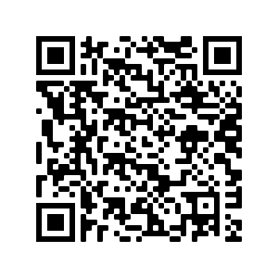
For any questions
Coronavirus hotline 1800 675 398 (24 hours)
Please keep Triple Zero (000) for emergencies only
To receive this document in another format phone 1300 651 160 using the National Relay Service 13 36 77 if required, or email Emergency Management Communications
<COVID-19@dhhs.vic.gov.au>.
Authorised and published by the Victorian Government, 1 Treasury Place, Melbourne.
© State of Victoria, Australia, Department of Health and Human Services, 14 October 2020.
Available at: DHHS.vic – coronavirus (COVID-19) <https://www.dhhs.vic.gov.au/coronavirus>

