Information to help you with your mental health during coronavirus (COVID-19)
Easy read information for people with disability

About this book
 | This book is about helping you look after your mental health.
 | Mental health means the way you feel and think.
Coronavirus has meant a lot of people’s lives have changed.
Coronavirus is also called COVID-19.
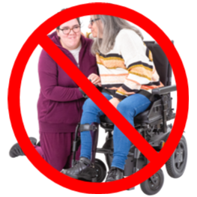 | You might not be able to see your friends and family.  You might not be able to do the things you want to do.
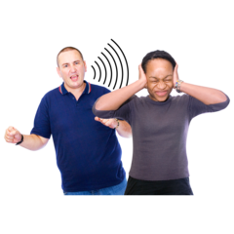 | This might be making you feel sad or worried or angry.
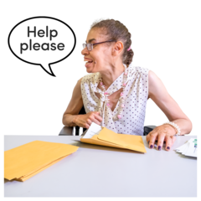 | This book has information about where you can get help.

Ways you can feel better
There are things you can do to feel better.

Make sure you know what is going on
It is important you get information from someone who knows what is happening.
A good place to get information is from the government.
You can find out information by looking at the Department of Health and Human Services website.
<https://www.dhhs.vic.gov.au/mental-health-resources-coronavirus-covid-19>
The website has information about coronavirus.
The website also has ideas about ways to look after your mental health.

2. Stay in touch with your friends and family
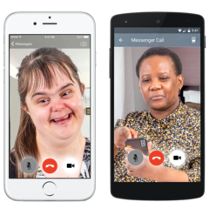 | It’s a good idea to keep talking to your family and friends.  This can make you feel better.
 | If you want to make new friends, you can join a group with other people with disability.
You can find these groups on the internet by visiting the peer connect website.
<https://www.peerconnect.org.au/>

3. Keep up your mental health treatment
 | Mental health treatments are the things that people do to make them feel better.
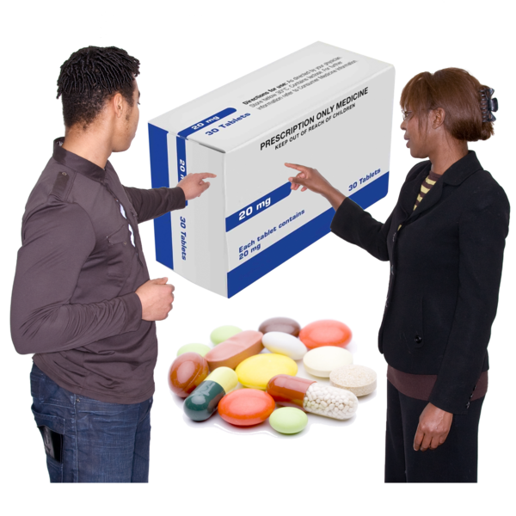 | Some people take medicine for their mental health.
 | Some people talk to a counsellor.
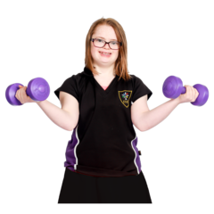 | Some people do exercise.  Whatever you do for your mental health you should keep doing it. This will make things easier for you.

4. Get help if you need it
If you feel really sad or worried there are lots of ways you can get extra help.
You can call the Disability Information Helpline on
1800 643 787
You can call the helpline:
Monday to Friday 8 am to 8 pm
Saturday and Sunday 9 am to 7 pm
The helpline can find you someone to talk to.
If you need someone to talk to now, you can call Beyond Blue on
1300 224 636
You can call this number anytime; they are always open to talk to people.
You can also talk to them over the internet. You can do this by visiting the Beyond Blue website. <https://www.beyondblue.org.au/>

To receive this document in another format phone 1300 880 043, using the National Relay Service 13 36 77 if required,
or email Office for Disability <ofd@dhhs.vic.gov.au>
Authorised and published by the Victorian Government, 1 Treasury Place, Melbourne.
© State of Victoria, Department of Health and Human Services, May 2020.
Available at Department of Health and Human Services Coronavirus page <https://www.dhhs.vic.gov.au/coronavirus>

